

REGULATIONS MADE IN TERMS OF

Basic Education Act 3 of 2020

section 125

Basic Education Regulations

Government Notice 331 of 2023

([GG 8229](http://www.lac.org.na/laws/2023/8229.pdf))

came into force on date of publication: 5 October 2023

The Government Notice that issues these regulations repeals Parts I to VI of the regulations contained in Government Notice 187/2002 ([GG 2841](http://www.lac.org.na/laws/2002/2841.pdf)) and the amendments to those regulations contained in Government Notice 15/2004 ([GG 3144](http://www.lac.org.na/laws/2004/3144.pdf)), which added Part VII. Thus, it has   
the effect of repealing these regulations in their entirety.

ARRANGEMENT OF REGULATIONS

PART 1

INTRODUCTORY PROVISIONS

1. Definitions

2. Quality education

PART 2

LEARNERS AT STATE SCHOOLS

3. Admission to State schools

4. School attendance at State schools

[The heading of this regulation in the text below is “Attendance at State schools”.]

5. Transfer of learner

6. Prefects and learners’ representative council

7. Election committee

8. Nomination and election of prefects and members of learners’ representative council

9. Powers and functions of prefects and learners’ representative council

10. Vacation of office by prefects and members of learners’ representative council

11. Meetings and decision of prefects and learners’ representative council

PART 3

HOSTEL AT STATE SCHOOL

12. Hostel committee

13. Vacation of office of member of hostel committee

14. Vacancies on hostel committee

15. Functions of hostel committee

16. Superintendent

17. Lodging of superintendent

18. Supervisory teacher or person

19. Hostel staff

20. Quotas for boarding in State hostel

21. Criteria for admission of boarder in State hostel

22. Exemption of parents from payment of hostel fees

23. Contribution to hostel development fund

24. Control over boarders

25. Medical attention of boarders

26. Accommodation during out weekends

27. Accommodation of persons other than learners

PART 4

SERVICE POINT

28. Establishment of service point

29. Head of service point

30. User of service point

31. Service point user fees

32. Committee of service point

33. Annual general meeting of users

34. Service point development fund

35. Handover of accounts and other financial documents

36. Closure of service point

PART 5

INSPECTIONS AND INVESTIGATIONS OF STATE SCHOOLS AND HOSTELS

37. Designation of quality assurance officers

38. Purpose of inspections

PART 6

SCHOOL BOARD OF STATE SCHOOL

39. Determination of constitution of school board of State school

40. Qualification as member of school board of State school

41. Election of members of school board of State school

42. Election and nomination of members of school boards of State school for learners with special education needs

43. Election of school board office-bearers

44. Meetings of school board and committees of school board

45. Confidentiality

46. Powers and functions of schools board

[The heading of this regulation in the text below is “Powers and functions of school board”.]

47. Expenses incurred by school board or committee of school board

PART 7

SCHOOL DEVELOPMENT FUND

48. Voluntary contributions to school development fund of state school

[The word “State” is capitalised in the heading of this regulation in the text below.]

49. School development fund account and investment

50. Bookkeeping

51. Function arranged in aid of school development fund

52. Payments from school development fund

53. Stores register, inventory and stock-taking

54. Appointment of auditor

55. Inspection by staff member of Ministry

56. Handover of assets when State school closed

PART 8

PRIVATE SCHOOLS, PRIVATE PART-TIME CENTRES AND HOSTELS

57. Registration of private schools and private part-time centres

58. Conditions to be complied with after registration of private schools and private part-time centres

59. Registration of private hostels or community hostels

60. Aid to private schools

[The heading of this regulation in the text below is “Aid to private schools or hostels”.]

61. Conditions for granting of aid to private schools or hostels

62. Curriculum, medium of instruction or examining body for private school

[The heading of this regulation in the text below is “Curriculum, medium of instruction   
or examining body for private school or private part-time centre”.]

63. Participation of private schools in national and regional training programmes and competitions

64. Inspections, monitoring and evaluation of private schools and hostels

[The heading of this regulation in the text below is “Inspections, monitoring and evaluation of private schools, private part-time centre and hostels”.]

PART 9

HOME SCHOOLING

65. Application for registration for home schooling

PART 10

HEALTH AND SAFETY AND GENERAL MATTERS   
AT STATE SCHOOLS AND HOSTELS

66. Access to school premises

67. Exemption of certain persons from application of regulation 67

68. Early release from school

69. School and hostel environment and infrastructure

70. Violence, illegal drugs and alcohol free schools and hostels

[The term “alcohol-free” is hyphenated in the heading of this regulation in the text below.]

71. Search and seizure

72. School activities needing approval of regional director

73. Organisation of school activities

74. Consent and indemnity

75. Transportation of learners

76. Participation in physical activities and sports

[The heading of this regulation in the text below is “Participating in physical activities and sports”.]

77. Occupational health and safety

78. Procedure for handling incidents at State schools and hostels

Annexure 1: Procedure for Handling Incidents at Schools and Hostels

Annexure 2: Number of School Board Members of State School

Annexure 3: Boarding and Lodging Fees

Annexure 4: Forms

**Form Regulation**

1. Application for admission of learner to State school and hostel ....... 3 and 22(4)

2. Application for exemption from electing prefects or establishing

learners’ representative council .................................................................... 9(4)

3. Application for partial or full exemption from payment of

hostel fees ................................................................................................... 23(1)

4. Nomination form for school parent or teacher of school to serve

as school board member ........................................................................... 42(14)

[Form 4 below is headed “Nomination form for a school parent   
or teacher of a school to serve as school board member”.]

5. Oath of secrecy by school board member ................................................. 42(24)

6. Application for registration as private school or part-time centre .............. 57(l)

[Form 6 below is headed “Application for registration   
of a private school / private part-time centre”.]

7. Certificate of registration as private school or part-time tuition centre ..... 57(5)

[Form 7 below is headed “Certificate of registration as   
private school or private part-time tuition centre”.]

8. Register of private schools and part-time tuition centres ........................... 57(7)\

[Form 8 below is headed “Register of private schools and private part-time centre”.]

9. Application for registration as private hostel or community hostel ............ 59(1)

10. Certificate of registration as private hostel or community hostel ............... 59(4)

11. Application for registration for home schooling ......................................... 65(1)

PART 1

INTRODUCTORY PROVISIONS

**Definitions**

**1.** In these regulations a word or an expression to which a meaning has been assigned in the Act has that meaning, and unless the context indicates otherwise -

“hostel committee” means a hostel committee of a school board established under regulation 12;

“hostel premises” includes any building, structure, land, and enclosure, which is under the control of a hostel;

“hostel staff” includes -

(a) a superintendent, supervisory teacher and supervisory person appointed on short term contract of employment; or

(b) a staff member appointed in terms of the Public Service Act to perform functions at a hostel such as hostel matrons and institutional workers that perform domestic functions in the hostel.

“school activity” means any educational, cultural, sporting or social activity of the school or hostel which takes place within or outside the school or hostel premises that falls outside the scope of the school curriculum;

“school parent” means a parent whose child is enrolled at a school;

“school premises” includes any building, structure, land, and enclosure, which is under the control of a school;

“service point” includes -

(a) an arts centre;

(b) a community learning and development centre;

(c) a community library;

(d) a cultural centre;

(e) monuments;

(f) a teachers’ resource centre; and

(g) any other establishment of the Ministry,

not being a school or part of a school, where service is provided to assist learners, teachers and other members of the public in any field of teaching, learning and entertainment;

“social worker” means a social worker as defined in section 1 of the Social Work and Psychology Act, 2004 (Act No. 6 of 2004);

**[The Social Work and Psychology Act 6 of 2004 has been   
replaced by the** **Health Professions Act 16 of 2024.]**

“superintendent” means a teacher designated as superintendent of a hostel in terms of regulation 16(1);

“supervisory teacher” means a teacher or person designated or appointed as supervisory teacher or person in terms of regulation 18(1);

“the Act” means the Basic Education Act, 2020 (Act No. 3 of 2020); and

“user” means a user of a service point registered under regulation 30.

**Quality education**

**2.** Subject to the guiding principles set out in section 3 of the Act, the Minister must, within the available resources, ensure the provision of quality education, including learning support and special education, which includes -

(a) learners who are healthy, well-nourished and ready to participate and learn, and supported in learning by their families and communities;

(b) environments that are healthy, safe, protective and gender-sensitive, and provide adequate resources and facilities;

(c) content that is reflected in relevant curricula and materials for the acquisition of basic skills, especially in the areas of assistive technology, sign language, literacy, numeracy and skills for life, and knowledge in such areas as gender, health, nutrition, HIV/AIDS prevention and peace;

(d) processes through which trained teachers use -

(i) learner-centred teaching approaches in well-managed classrooms; and

(ii) schools and skillful assessment to facilitate learning and reduce disparities; and

(e) competencies that encompass knowledge, skills and attitudes, and are linked to national goals for education and positive participation in society.

PART 2

LEARNERS AT STATE SCHOOLS

**Admission to State schools**

**3.** (1) An application for admission of a learner to a State school referred to in section 20(1) of the Act must be made in the form of Form 1 set out in Annexure 4.

(2) A parent applying for admission of a child in any grade at a State school must submit, as proof of the appropriate age and correct name of the child -

(a) a birth certificate; or

(b) a passport; or

(c) a medical passport; or

(d) a baptism card; or

(e) a sworn declaration by the parent; or

(f) a declaration from -

(i) the regional councillor concerned; or

(ii) the headmen of the village.

(3) A parent who enrols a child with any of the documents listed in paragraph (b) to (f) must ensure that they obtain a birth certificate for the child before the end of primary school.

[The singular word “paragraph” should be the plural word   
“paragraphs” to be grammatically correct.]

(4) A State school must admit a child at a State school -

(a) if the child reaches the age of -

(i) five years before January in the year in which the admission is applied for in respect of Pre-Primary level; or

(ii) six years before January of the year in which the admission of the child is applied for in respect of Grade 1; or

(b) during the course of the first 15 school days of the first school term of the year concerned, that child -

(i) has already been admitted to one school during the course of those days and is only being transferred to another school;

(ii) for health reasons, pregnancy, physical violence, sexual abuse or other reason approved in writing by the regional director on a request from the parent, was unable to attend State school or another school during the course of those days; or

(iii) is subject to compulsory school attendance in terms of section 9(1) of the Act.

(5) If a child older than six years -

(a) has not been enrolled in any school; or

(b) has been enrolled in a school but could not complete his or her primary education,

and is enrolled in a grade appropriate to his or her age, he or she, in order to be at same level with others, must receive appropriate support from the State school where he or she is enrolled in such manner and within such time-limits as the regional director and the school management may direct.

[The word “the” appears to have been omitted before the phrase “same level”.]

(6) A State school may not admit a child in any grade if the child -

(a) is older than 10 years of age; and

(b) has never attended school before,

unless evaluation of the child as to which grade is appropriate to him or her has been conducted by the State school and approved by the Executive Director.

(7) If the Executive Director has not approved the admission of the child referred to in subregulation (6) in any grade at a State school and the child is under 16 years of age, the Executive Director must ensure the admission of the child to a literacy or adult education programme.

(8) A State school may admit in any grade a person who is older than 16 years but not older than 21 years of age, if the person -

(a) had already been enrolled in a State school the previous year and was promoted to the next grade; or

(b) produces proof that he or she had been previously enrolled and attended school but for health reasons could not continue attending school.

(9) A person who is older than 21 years of age may be admitted to adult education and literacy programmes referred to in section 31(1) of the Act.

**Attendance at State schools**

**4.** (1) If a learner is absent from a State school, it is the responsibility of the parent or the superintendent in the case of a boarder to inform the principal of the absence of the learner.

(2) If a learner is absent for more than two consecutive school days because of illness, the principal of a State school may require a medical certificate issued by a medical practitioner or senior nurse on the establishment of a hospital or clinic, which -

(a) indicates the nature of the illness of the learner; and

(b) declares that the learner is unable to attend school during a specified period.

(3) If a learner is absent from a State school for two consecutive school days, the principal must ascertain the cause for the absence of the learner, if it is not known.

(4) If the cause contemplated in subregulation (3) is that -

(a) the parent of the learner referred to in that subregulation has taken the learner out of the State school contrary to the Act or these regulations; or

(b) the learner is absent from a State school without good cause,

the principal must direct the parent of the learner in writing to return such learner to the school within two days of receipt of the directive.

(5) If a parent fails or refuses to comply with the directive referred to in subregulation (4) -

(a) the principal must refer the matter to the Executive Director; and

(b) the Executive Director must issue a notice in writing to the parent advising the parent to comply with the directive within the period specified in the notice.

(6) If the parent does not comply with the notice referred to in subregulation (5)(b), the Executive Director with the assistance of the principal must take all reasonable steps to ensure the learner is returned to school.

**Transfer of learner**

**5.** (1) The Executive Director -

(a) after consultation with the parents of a learner, may transfer learners from a State school to another State school as a result of -

(i) any division, classification or combination of schools as contemplated in section 38 of the Act; or

(ii) the closure of a school in terms of section 43 of the Act; or

(b) after consultation with the parent, transfer a learner in need of special education from a mainstream State school to a resource school;

(c) on application made by the parent, may transfer a learner from a State school to another State school.

(2) The school from which the learner is being transferred as contemplated in subregulation (1) must submit a copy of the learners latest report card, the cummulative record card and the birth certificate of the learner to the receiving school.

[The word “cumulative” is misspelt in the *Government Gazette*, as reproduced above.

The word “learners” should be the possessive “learner’s” to be grammatically correct.]

(3) The Executive Director, after having transferred a learner from a State school to another State school in terms of subregulation (1), must immediately inform the parent in writing of the transfer.

**Prefects and learners’ representative council**

**6.** (1) Prefects or learners’ representative council elected or established in terms of section 27(1) and (2) of the Act, respectively -

[The phrase “learners’ representative council” should be either “a learners’ representative council” or “learners’ representative councils” to fit the sentence structure.]

(a) must be constituted annually during the last school term and before the final examinations start; and

(b) conducts its affairs in terms of its constitution subject to these regulations.

(2) A prefects or learners’ representative council must be constituted as follows -

(a) an equal number of elected boys and girls, except where a school enrolls only boys or girls, and which number is one member for every 40 learners of the school, rounded off to the nearest even number;

(b) a teacher designated by the principal from amongst the senior staff members of the school -

(i) to be the liaison person between the prefects or learners’ representative council and the school management; and

(ii) who may attend any meeting of the prefects or learners’ representative council, but does not have a right to vote.

(3) Within seven days after the election of prefects or learners’ representative council, the elected members must meet under the chairmanship of the liaison teacher and, by secret ballot and simple majority vote, elect the prefects or learners’ representative council office-bearers of whom at least one must be a female -

(a) a chairperson;

(b) treasurer; and

(c) a secretary.

(4) A resource school may apply to the Minister on Form 2 set out in Annexure 4 for exemption from electing prefects or establishing learners’ representative council in terms of section 27(1) or (2) of the Act.

[The word “a” appears to have been omitted before the phrase “learners’ representative council”.]

**Election committee**

**7.** (1) The principal must appoint an election committee consisting of the following four members -

(a) a senior teacher as chairperson and another teacher, both nominated by the teaching staff, and

(b) two learners nominated by the learners.

(2) The election committee must organise and conduct the election referred to in regulation 8, count the votes and announce the results of the election at a time and place approved by the principal.

**Nomination and election of prefects and members of learners’ representative council**

**8.** (1) The election committee referred to in regulation 7, after consultation with the teaching staff of the school and the learners, must determine the procedure for the nomination and election of candidates for the election as prefects or members of the learners’ representative council.

(2) A learner who has been found guilty of misconduct under the general rules of conduct made in terms of section 22(1) of the Act or the code of conduct adopted as contemplated in section 22(2) of the Act during the 12 months preceeding the election for prefects or members of learners’ representative council may not be nominated for election.

[The word “preceding” is misspelt in the *Government Gazette*, as reproduced above.]

(3) Only a learner who will be in one of the two highest grades at the school in the following year may be nominated for election as a prefect or member of the learners’ representative council.

(4) A learner who is an existing prefect or member of the learners’ representative council may also nominate a candidate, and be nominated for re-election.

(5) The nomination and election of prefect or members of the learners’ representative council is an internal matter of the school and no campaigning, influence or involvement by a person, organisation or group from outside the school is allowed.

**Powers and functions of prefects and learners’ representative council**

**9.** (1) The functions of prefects or learners’ representative council as a highest body of elected leaders of the learners of the school are -

[To be grammatically correct, the phrase “learners’ representative council” should be preceded by the word “a” or “the”, and the phrase “a highest body” should be “the highest body”.]

(a) to promote the best interest and welfare of the school and its learners;

(b) to act as the liaison between learners and the school management;

(c) with approval of the principal, to undertake projects and programmes aimed at -

(i) improving and maintaining the school environment and facilities;

(ii) providing cultural, sport and social activities for learners; and

(iii) improving the health and welfare of learners;

(d) to assist the principal and teachers to ensure adherence to the code of conduct of the school by all learners so as to create and maintain an orderly and disciplined school environment conducive to learning;

(e) to foster a spirit of mutual respect, good manners and morality among the learners;

(f) to promote and maintain discipline among learners and promote the general welfare of the school;

(g) to foster participation in school activities;

(h) to provide a training ground for developing leaders;

(i) to help each learner to feel at home in the school;

(j) to promote orderliness in the school;

(k) to assist school management in implementing the school policies; and

(l) to perform any other reasonable tasks assigned to the prefects or learners’ representative council by the principal.

(2) The prefects -

(a) may establish committees for specific functions or projects of prefects, which may include learners who are not prefects as members; and

(b) must designate a prefect as chairperson of such committee established under paragraph (a).

(3) The learners’ representative council -

(a) may establish committees for specific functions or projects of the learners’ representative council, which may include learners who are not members of the learners’ representative council as members; and

(b) must designate a member of the learners’ representative council as chairperson of such committee established under paragraph (a).

**Vacation of office by prefects and members of learners’ representative council**

**10.** (1) A prefect or member of the learners’ representative council vacates office, if such member -

(a) is found guilty of misconduct under the general rules of conduct made in terms of section 22(1) of the Act or the code of conduct adopted as contemplated in section 22(2) of the Act;

(b) resigns from office after giving a 30 days’ notice to the chairperson of the prefects or learners’ representative council; or

(c) ceases to be a learner of the school.

(2) If a vacancy occurs, as contemplated in subregulation (1), during the term of the elected prefects or learners’ representative council, the vacancy is filled by a learner who is next on the election list in terms of votes.

**Meetings and decision of prefects and learners’ representative council**

**11.** (1) A prefects or learners’ representative council must hold at least two meetings during each school term.

[It appears that the phrase “A prefects” should be “The prefects” to fit the context.]

(2) The secretary of the prefects or learners’ representative council must -

(a) keep minutes of the proceedings of all meetings of prefects or learners’ representative council; and

(b) provide minutes of proceedings of any meeting to the members for corrections before the next meeting is held.

(3) The chairperson of prefects or learners’ representative presides all meetings of prefects or learners’ representative council, and in the absence of the chairperson, the members present may elect any member to preside over that meeting.

Several words appear to have been omitted in subregulation (3). The first phrase may have been intended to read “The chairperson of the prefects or learners’ representative council presides over   
all meetings of prefects or the learners’ representative council…”.

(4) The majority of all the members of prefects or learners’ representative council forms a quorum for any meeting of prefects or council.

(5) The majority vote of members present at any meeting of prefects or learners’ representative council constitutes a decision of the prefects or learners’ representative council.

PART 3

HOSTEL AT STATE SCHOOL

**Hostel committee**

**12.** (1) A school board of a State school with a hostel must establish a hostel committee under section 62 of the Act for the efficient running of the hostel.

(2) A hostel committee consists of not less than five and not more than seven members, including the superintendent who is a member by virtue of his or her office.

(3) The school board may -

(a) designate for its membership any person to serve on the hostel committee; and

[The context indicates that the word “for” should be “from”.]

(b) appoint any person from any of the following persons to serve on the hostel committee -

(i) parents of boarders; and

(ii) prefects and learners’ representative council who are boarders at the hostel.

(4) A member of a hostel committee holds office -

(a) for as long as such member is a member of the school board concerned; or

(b) for such period, not exceeding three years, as the school board may determine in writing at the time of appointment of the member, in case of a member who is not a school board member.

(5) Where learners from different State schools are boarding in the same hostel -

(a) each school board of every such school must designate at least one school board member to represent such school on the hostel committee of that hostel; and

(b) members of the hostel committee may appoint an additional member from the school parents of the learners.

(6) A school parent may not be appointed as member of a hostel committee if such parent is the spouse of a staff member who is on the establishment of that State hostel.

(7) Subject to subregulation (8), the superintendent is a member of the hostel committee by virute of his or her office, and may take part in the deliberations of any matter before the committee, but has no right to vote.

[The word “virtue” is misspelt in the *Government Gazette*, as reproduced above.]

(8) If a member of the hostel committee has informed the committee of the existance of a possible conflict of interest during a meeting of the committee, the committee must deliberate on the said possible conflict and determine whether the conflict is material and whether the member must be excluded from the meeting or from the deliberations on the agenda item on which he or she is conflcited.

[The words “existence” and “conflicted” are misspelt   
in the *Government Gazette*, as reproduced above.]

(9) A school board must designate any member of the hostel committee to be the chairperson of the committee.

(10) A hostel committee must appoint one of its members as secretary of the committee.

(11) The secretary of a hostel committee, within 14 days of his or her appointment, must submit to the Executive Director his or her name and address and the names and addresses of the chairperson and other hostel committee members.

**Vacation of office of member of hostel committee**

**13.** (1) A school parent member of a hostel committee vacates office, if such member -

(a) has been absent from three consecutive meetings of that committee without the prior approval of the chairperson of the committee; or

(b) resigns from office after giving a 30 days written notice to the chairperson of the committee, and if such member is the chairperson of the hostel committee, on written notice to the chairperson of the school board.

(2) A school board may remove from office a school parent who is a member of a hostel committee, if the school board is satisfied that such member -

(a) is physically or mentally incapable of performing his or her functions;

(b) has conducted himself or herself dishonestly or in a disgraceful manner; or

(c) has neglected his or her functions,

after giving written notice to that member and after affording him or her a reasonable opportunity to be heard.

**Vacancies on hostel committee**

**14.** (1) A vacancy on a hostel committee arising from any circumstance referred to in section 64 of the Act or regulation 13 must be filled for the unexpired portion in the manner referred to in regulation 12.

(2) The secretary of the hostel committee must, within 14 days of filling a vacancy as contemplated in subregulation (1), furnish the Executive Director with the name and address of any member of a hostel committee who has been appointed.

**Functions of hostel committee**

**15.** (1) The functions of a hostel committee in relation to a hostel concerned are -

(a) to exercise overall supervision over the hostel;

(b) to advise the superintendent and the school board in matters pertaining to the hostel;

(c) to receive regular reports on the affairs of the hostel;

(d) to inform itself on the conditions of hostel facilities and advise the school board;

(e) to receive representations and grievances of boarders and parents of boarders and advise the superintendent with regard to such representations and grievances;

(f) to investigate and advise on such matters as the school board concerned or the Executive Director may refer to it for investigation and report;

(g) to exercise overall control over the management, bookkeeping and affairs of the hostel development fund;

(h) to recommend hostel rules and a code of conduct for boarders to the school board; and

(i) to promote the general health, welfare and hygiene of boarders.

(2) Nothing contained in subregulation (1) may be construed as giving a hostel committee or any member any authority to instruct any hostel staff to perform or refrain from performing any act.

**Superintendent**

**16.** (1) Subject to the Public Service Act and the remuneration, allowances and conditions of service as recommended by the Public Service Commission, the Executive Director must designate a teacher on the establishment of a State school for which a hostel has been established to be a superintendent for that hostel.

(2) Subject to subregulations (4) and (5), a superintendent is designated for such period, not exceeding three years, as the Executive Director may determine, and may be re-designated at the expiration of such period.

(3) A superintendent, subject to these regulations and the direction, supervision and control of the principal -

(a) has direct supervision and control over the staff, boarders, buildings, equipment and materials of the hostel;

(b) is responsible for the management of the hostel which includes planning, organisation, guidance and exercising control of the different hostel management areas;

(c) may recommend rules for the internal management and behavior of boarders, including periods of study to the hostel committee;

(d) determines effective measures and procedures to control access of persons to the hostel to ensure the safety and security of boarders and staff of the hostel and the protection of properties;

(e) draws up an annual plan for the hostel which he or she must submit at the end of September in each year to the school board for approval.

(4) Subject to the Public Service Act, the Executive Director may withdraw the designation of a teacher as superintendent, if the Executive Director -

(a) has offered the superintendent an opportunity to be heard; and

(b) is satisfied that the superintendent is not performing his or her functions to the best interest of the boarders.

(5) A superintendent -

(a) is simalteously suspended from his or her position as superintendent, if he or she is suspended as teacher in terms of the Public Service Act; or

[The word “simultaneously” is misspelt in the *Government Gazette*, as reproduced above.]

(b) must vacate office of the superintendent if found guilty of misconduct in terms of the Act or the Public Service Act.

[The word “the” appears to have been omitted before the word “office”.]

**Lodging of superintendent**

**17.** (1) A superintendent may lodge in the hostel for which he or she has been designated as superintendent, or in a residence on the premises of the State school or hostel concerned.

(2) Subject to subregulation (3), a superintendent -

(a) may lodge in the official accommodation with his or her dependant children under the age of seven years free of charge; and

(b) is entitled to free meals.

(3) During school holidays the persons referred to in subregulation (2) are entitled to official accommodation free of charge, but are not entitled to free meals or the use of hostel supplies or services, except the use of electricity and water.

(4) The spouse, dependant children of seven years of age and older or other relatives of a superintendent sharing accommodation in a State hostel with the superintendent must -

(a) pay for such accommodation as stated in Part 2 of Annexure 3; and

(b) provide for their own meals, supplies and services.

(5) If a superintendent is granted leave, other than sick leave, for a period -

(a) longer than 30 days he or she, with the written permission of the Executive Director, may retain the position of superintendent and continue lodging and boarding with his or her spouse, dependant children and relatives in the official accommodation free of charge; or

(b) longer than a school term the superintendent and his or her spouse, dependant children and relatives must vacate such official accommodation on the day such leave commences.

(6) If a superintendent is granted sick leave in terms of the Public Service Act for a period exceeding 60 days, he or she, with the written permission of the Executive Director, may continue lodging and boarding with his or her spouse, dependant children and relatives in the official accommodation free of charge for such period as the Executive Director may determine.

(7) A superintendent who is not re-designated as contemplated in regulation 16(2) must vacate the offical accommodation within the time period as notified to him or her by the Excutive Director in writing.

[The words “official” and “Executive” are misspelt   
in the *Government Gazette*, as reproduced above.]

**Supervisory teacher or person**

**18.** (1) The Executive Director, with the concurrence of the principal of a State school and the superintendent, and based on the staffing norms for supervisors in a State hostel, may -

(a) designate, from amongst the teaching staff on the establishment of the school, a teacher or teachers to assist as supervisory teacher in the hostel; or

(b) subject to the Public Service Act, appoint on contract any other person to assist as supervisory person in the hostel.

(2) A person designated or appointed in terms of subregulation (1) must be of the same gender as the boarders accommodated in the hostel for which he or she has been designated or appointed.

(3) The Executive Director may, in writing, with the concurrence of the principal of a State school and the superintendent, at any time terminate a designation or appointment made under subregulation (1), after giving the person concerned an opportunity to be heard.

(4) A supervisory teacher or person must -

(a) perform his or her functions under the direction and control of the superintendent; and

(b) comply with the instructions given by the superintendent in relation to his or her functions as supervisory teacher or person.

(5) A supervisory teacher or person is entitled -

(a) to such remuneration and allowances and other conditions of services as may be determined in accordance with the Public Service Act;

(b) to free boarding and lodging in the hostel for which he or she has been appointed, or in a residence on the premises of the hostel; and

(c) to free meals and all hostel supplies and services, and his or her children under the age of seven years are entitled to free boarding, lodging, meals and all hostel supplies and services, when on duty.

(6) A spouse, dependant children of seven years of age and older or other relatives of a supervisory teacher or person sharing accommodation in a State hostel with the supervisory teacher must -

(a) pay for their accommodation as stated in Part 2 of Annexure 3 into the State Revenue Fund; and

(b) provide for their own meals, supplies and services.

(7) During school holidays a supervisory teacher or person and his or her dependant children under seven years of age are entitled to free lodging in the official accommodation, but are not entitled to free meals or use of hostel supplies or services, except the use of electricity and water.

(8) If a supervisory teacher or person is granted leave, other than sick leave, for a period -

(a) longer than 30 days he or she, with the written permission of the Executive Director, may retain the position of supervisory teacher or person and continue lodging and boarding with his family in the official accommodation; or

(b) longer than a school term he or she and his or her spouse, dependant children and relatives must vacate the official accommodation.

(9) If a supervisory teacher or person is granted sick leave in terms of the Public Service Act for a period exceeding 60 days, he or she, with the written permission of the Executive Director, may continue lodging and boarding in the official accommodation free of charge for such period as the Executive Director may determine, and his or her spouse, dependant children and relatives may continue lodging and boarding until such time in accordance with the applicable conditions.

(10) A supervisory teacher or person whose designation or appointment has been terminated as contemplated in subregulation (3) must vacate the offical accommodation within the time period as notified to him or her by the Executive Director in writing.

[The word “official” is misspelt in the *Government Gazette*, as reproduced above.]

**Hostel staff**

**19.** (1) The Executive Director creates, retains or abolished posts of chief hostel matron, matron and institutional workers on the establishment of each hostel according to the posts provisioning norms approved by the Public Service Commission.

[The word “abolishes” is misspelt as “abolished”   
in the *Government Gazette*, as reproduced above.]

(2) The chief hostel matron and, in the case of hostels that accommodate primary learners, the hostel matron (child care) and their dependant children under the age of seven years are entitled to free lodging in the hostel, and regulation 17(3), (4), (5) and (6) apply with the necessary changes.

(3) In terms of section 92 of the Act, a hostel staff, on assumption of duty and annually, is medically examined for tuberculosis and other infections or contagious diseases, but such staff member may exercise the option referred to in section 92(4) of the Act.

[The word “member” appears to have been omitted after the phrase “a hostel staff”.]

(4) If during a medical examination of any hostel staff member under this regulation any case of tuberculosis, infections or contagious disease is found -

(a) the superintendent must immediately notify the Executive Director in writing; and

(b) the Executive Director on receipt of notification under paragraph (a) must determine the appropriate steps to be taken, subject to the Public Service Act.

(5) Except staff members mentioned in subregulation (2), matrons and institutional workers must receive free meals at the hostel when they are on duty and physically present at the hostel during regular meal times.

(6) All meals provided at a hostel are taken -

(a) in the dining room or another suitable place designated by the superintendent; or

(b) at a place of a person entitled to such meals, if the person is unable to take meals at the designated place due to illness.

(7) A superintendent, supervisor and other staff of a State hostel or any other person may not remove any food, supplies, accessories, equipment or other hostel property from the hostel or the hostel premises, unless written authorisation is obtained from the Executive Director.

(8) Any person referred to in subregulation (7) who contravenes that subregulation commits an act of misconduct for which disciplinary action may be taken against him or her in accordance with the Public Service Act.

**Quotas for boarding in State hostel**

**20.** If a State hostel is established in terms of section 38 of the Act, the Executive Director must determine, in writing, the number of boarders in a State hostel, and such number may not be exceeded without the written approval of the Executive Director.

**Criteria for admission of boarder in State hostel**

**21.** (1) Subject to regulations 17, 18 and 19, only learners may board in a State hostel.

(2) A learner may board in a State hostel, if such learner is a learner of the school to which the hostel is attached, and -

(a) his or her parent is ordinarily resident in Namibia or resident outside Namibia and the learner is in possession of a valid study permit and a written approval of the school board; and

(b) does not live within a 5 km radius from the hostel, or within the same local authority area in which the hostel is located.

(3) Despite subregulation (2)(b), on a written application by a parent, learner or any concerned person and on the written recommendation of a social worker, the Executive Director, after consultation with the superintendent, may approve a learner to board in a hostel, if such learner is a learner -

(a) whose parent is absent from home for a considerable period and there is no other person to take care of the learner;

(b) living with a disability that warrants hostel accommodation;

(c) who is an orphan, disadvantaged, marginalised or does not receive proper guardianship at a place where he or she lives, or is at risk of dropping out of school due to other valid reasons;

(d) who is being neglected or abused in one way or the other at a place where he or she lives; or

(e) who lives in unsafe conditions.

(4) A parent whose learner desires accommodation in a hostel may apply to the superintendent for admission of the learner in the form of Form 1 set out in Annexure 4.

(5) A parent whose learner has been admitted in a State hostel must pay the hostel fees as set out in Annexure 3.

(6) A learner may not be re-admitted to the hostel if he or she failed a grade in the preceding academic year, except where proof is provided which shows that the academic performance of the learner was affected by his or her illness or illness of a close relative or death of a close relative which affected the academic performance of the learner.

**Exemption of parents from payment of hostel fees**

**22.** (1) A parent whose learner is boarding in a State hostel and who cannot afford to pay hostel fees in terms of section 67(3) of the Act may apply, in the form of Form 3 set out in Annexure 4, to the school board for -

(a) partial or full exemption from payment of hostel fees, or approval to pay school fees in kind; or

(b) full exemption from payment of hostel development fund, or approval to pay hostel development fund in kind.

(2) A parent applying for exemption as contemplated in subregulation (1) must provide the following information -

(a) the name, grade and date of birth of his or her child or children enrolled at the school;

(b) the name, grade and date of birth of other children enrolled at other schools, in a form of Statement written under oath that he or she is responsible for such other children’s school development fund contributions and other fees applicable to them;

[The phrase “in a form of Statement written under oath”   
should be “in the form of a statement written under oath”.]

(c) the name, residential address, postal address and alternative contact details of the parent;

(d) occupation, employer and annual or monthly income of the parent, or both parents, where applicable, or particular of any other income the parent receives;

(e) immovable and moveable property owned by the parent;

(f) a motivation letter for the application for full or partial exemption; and

(g) the ability of the parent to make a hostel development fund contribution in kind.

(3) A school board that considers to fully or partially exempt a parent from payment of hostel fees under section 67(2) of the Act must follow the requirements and procedures provided in this regulation.

(4) A statement of annual or monthly income required under subregulation (2)(d) which is not a salary slip must be substantiated -

(a) by documentation from the employer of the parent; or

(b) by a signed statement from a community leader, church leader or any reliable person who is familiar with the social and financial position of the parent.

(5) In the case where both biological parents of a learner are deceased, the learner -

(a) is classified as an orphan; and

(b) is exempted from payment of hostel fees, if there is proof that there is no alternative accommodation for the learner.

(6) On receipt of the application for exemption referred to in subregulation (1) -

(a) a school board must consider the application and make its recommendation, in writing, to the Minister within 15 days of receipt; and

(b) the Minister must decide within 30 days of receipt of the recommendation of the school board.

(7) After considering the application for exemption, the school board must -

(a) recommend, either -

(i) the full or partial exemption from payment of hostel fees;

(ii) the refusal of the exemption and give reasons; or

(iii) the approval or refusal of payment of hostel fees in kind, and give reasons in case of a refusal; and

(b) on receipt of the decision of the Minister, inform the applicant in writing of the decision.

(8) A parent may pay the hostel fees, either for the full year, each school term or monthly, and the school board must ensure that an effective bookkeeping system is maintained when recording all payments and issuing receipts.

(9) A learner may not be denied enrolment at a State school solely on the ground that the parent failed to pay the hostel fees for the previous year.

(10) Despite subregulation (9), a parent who fails to pay the hostel fees is held liable for all fees in arrear and must commit himself or herself to one of the methods of payment referred to in subregulation (8), otherwise a civil action may be taken against the parent.

(11) The school board may accept a payment of hostel fees in kind in the case where a parent is unable to make a financial contribution, and offers to render services to the school or hostel which may include -

(a) the maintenance and renovation work on the buildings and equipment of the school or hostel and the cleaning of the school or hostel premises;

(b) working with or assisting school staff during bazaars, sport days or other occasions;

(c) assisting with coaching of sport teams or cultural activities of learners; or

(d) any other service or contribution which the school board considers to be beneficial to the school and the learners.

**Contribution to hostel development fund**

**23.** (1) A boarder in any State hostel or any other hostel under the control of the State is required by section 67(2)(b) of the Act to pay a contribution to the hostel development fund, and regulation 22(11) applies with the necessary changes to the payment of contribution to the hostel development fund.

(2) A school board at a State hostel or any other hostel under the control of the State -

[There are no paragraphs labelled (a) and (b) in the *Government Gazette*.]

(c) after consultation with the school parents; and

(d) with the approval of the Executive Director,

determines the amount of hostel development fund to be paid by boarders at such hostels.

**Control over boarders**

**24.** A superintendent -

(a) acts in the place of a parent;

(b) has control over, and apply discipline to, the boarders in the hostel for which he or she has been designated; and

[The phrase “apply discipline” should be “applies discipine”   
or “may apply discipline” to be grammatically correct.]

(c) exercises and performs the powers and functions under these regulation -

[The phrase “these regulation” should be “these regulations”.]

(i) during the period commencing on the arrival for boarding in the hostel until the date of departure of the boarder from the hostel at the closure of each school term; and

(ii) whether or not a boarder is inside or outside the hostel or school premises.

**Medical attention of boarders**

**25.** (1) The parent of a boarder is responsible for the medical attention and expenses of the boarder.

(2) Despite subregulation (1), the Executive Director must provide to each superintendent for use by the boarders in the hostel such medical supplies or first aid equipment as he or she may consider necessary.

(3) The superintendent is not allowed to give any medication from the medical supplies referred to in subregulation (2) to a learner without the verbal consent of the parent of the learner.

(4) The superintendent must ensure that a boarder in State hostel in need of medical attention outside the hostel is transported to a nearest medical centre, clinic or hospital as soon as practicable.

[The word “a” appears to have been omitted before the phrase “State hostel”,   
and the phrase “a nearest medical centre, clinic or hospital” should be   
“the nearest medical centre, clinic or hospital”.]

**Accommodation during out weekends**

**26.** A boarder may board in a hostel during an out weekend with a prior written approval of the Executive Director.

**Accommodation of persons other than learners**

**27.** (1) The Executive Director, at the request of the principal of a State school or the superintendent concerned and after consultation with the school board, may grant written approval that persons other than boarders may temporarily be granted boarding in the hostel.

(2) Persons referred to in subregulation (1) must pay such fees for the boarding and lodging as the Minister, with the consent of the Minister responsible for finance, may determine.

(3) The boarding and lodging fees is -

[The verb “is” should be “are” to accord with the subject “fees”.]

(a) set out in Annexure 3; and

(b) paid into the State Revenue Fund and a staff member who receives the fees must deposit the fees into that account within 24 hours of receipt.

PART 4

SERVICE POINT

**Establishment of service point**

**28.** (1) Before establishing a service point under section 38(2) of the Act to provide various services to learners, teachers and community members, the Minister -

(a) must consult with the regional authority council or local authority council and local community in the area in which the service point is to be located;

(b) may collaborate with any office, ministry or agency, an educational institution, or a nongovernmental body having similar objectives to those of the Ministry.

(2) The Executive Director must keep and maintain a register of service points referred to in subregulation (1), indicating at least the name, location, facilities available, and contact details of the service point.

**Head of service point**

**29.** (1) The Executive Director, for each service point, must appoint a staff member to be the head of service point.

(2) The head of service point -

(a) must administer the service point and perform the functions imposed by these regulations or assigned in writing to him or her by the Executive Director; and

(b) is by virtue of his or her office a member of the committee of service point referred to in regulation 33, but has no right to vote and serves as a secretary to the committee.

**User of service point**

**30.** (1) A person may apply for registration as a user of a service point for any period of not more than three years in a form determined by the service point concerned.

(2) A user -

(a) may be issued with an identification card in a form determined by the service point concerned to give him or her access to a service point; and

(b) who is not in possession of identification card may be refused access to the service point by staff or volunteers at the service point.

[The word “an” appears to have been omitted before   
the term “identification card” in paragraph (b).]

**Service point user fees**

**31.** (1) The committee of a service point may charge -

(a) fees for -

(i) registration as user;

(ii) the use of specified facilities at a service point; or

(iii) specified services rendered by staff and volunteers at a service point; or

(b) fines for non-compliance with the rules of the service point,

as the committee, with the concurrence of the Executive Director, may determine at a meeting of the committee.

(2) The head of a service point must display or cause to be displayed the fees and fines determined as contemplated in subregulation (1) in a conspicuous place at the service point.

**Committee of service point**

**32.** (1) Each service point must have a committee to assist the head of service point in the running of the service point.

(2) A committee of service point consists of seven members appointed by the Executive Director -

(a) four persons nominated for appointment by the annual general meeting of the users of a service point after an election for that purpose;

(b) three persons from a list of responsible persons in the local community nominated for appointment, after consultation with the regional council concerned, by the head of service point 30 days before the annual general meeting of users.

(3) The members of a committee of service point must elect a chairperson, deputy-chairperson, treasurer and secretary.

(4) Elected members of a committee of service point serve until the next annual general meeting.

(5) The secretary of a committee of service point must convene the first meeting of the committee within 14 days after the annual general meeting.

(6) A member of a committee of service point provides services to the committee on a voluntary basis for the interest of the Namibian child, teachers and local community, therefore is not entitled -

(a) to remuneration for being such member; or

(b) to transport or accommodation allowance for being such member,

but such member may be compensated for transport expenses incurred by him or her for which the service point committee is liable, if the committee has given a prior approval based on valid grounds.

(7) A committee of a service point must, at a meeting of the committee, determine rules of the service point and cause such rules to be reduced to writing, subject to such guidelines and restrictions as the Executive Director may determine.

(8) A committee of a service point may -

(a) recruit and utilise volunteers to assist in the work of the service point, and such volunteers may not receive any monetary reward; or

(b) enter into agreements or contracts to further the work of the service point, and if there are any financial implications, such agreement or contract must first be approved by the Executive Director.

(9) The secretary of the committee of service point must keep minutes of all meetings of the committee, and the Executive Director may at any time request copies of the minutes of any meeting of the committee.

(10) The Executive Director may attend, or assign a staff member of the Ministry to attend, any meeting of the committee of a service point as an observer or advisor.

(11) The majority of the members of a committee of a service point forms a quorum for a meeting of the committee.

(12) The majority of members present at a meeting constitutes a decision of the committee, and in the event of an equality of votes on any question the person presiding at a meeting of a committee has a casting vote, in addition to his or her deliberative vote.

(13) Meetings of a committee of service point are held at times and places as determined by the chairperson of the committee.

[The word “a” appears to have been omitted before the term “service point”.]

(14) A committee of a service point must meet at least three times per year.

(15) The head of a service point must open a banking or post office savings bank account for the purposes of a service point development fund established in terms of regulation 35.

(16) If a member of a committee of a service point resigns from the committee, or dies, or otherwise vacates his or her office, the committee must appoint a suitable person to replace him or her for the remainder of the period up to the next annual general meeting, and -

(a) if the member to be replaced was elected by the users then the substitute must be out of users;

(b) if the member to be replaced was nominated for appointment by the head of service point, then the substitute is appointed after consultation with the regional council in which the service point is located;

[The word “the” appears to have been omitted before the term “service point”.]

(c) if any replacement is made the Executive Director must be notified immediately of all such changes in the membership of the committee.

(17) If the Executive Director has reason to believe that it is in the interest of the service point or Ministry to terminate the service of a member of a service point, the Executive Director -

(a) after consultation with the committee of service point concerned; and

[The word “the” appears to have been omitted before the term “service point”.]

(b) after having -

(i) informed the member in writing of the intention to terminate his or her service as member of the service point; and

(ii) given the member an opportunity to make representations, either orally or in writing,

may terminate the service of the member.

**Annual general meeting of users**

**33.** (1) The head of service point must -

[The word “a” appears to have been omitted before the term “service point”.]

(a) convene an annual general meeting of users to take place on or before March each year;

(b) send written notices to all users 30 days before the annual general meeting takes place.

(2) The chairperson of the committee of a service point, or his or her deputy, presides at the annual general meeting.

(3) The majority of the users of the service point present form a quorum for the holding of an annual general meeting.

(4) If the quorum required is not present at the meeting convened in terms of this regulation, the secretary of the committee of a service point must convene a second meeting within 30 days, and if the required quorum is still not present at the second meeting, the users present forms a quorum.

(5) The head of a service point must -

(a) submit a report on the activities of the service point for the previous year at the annual general meeting;

(b) lay the financial report and the income and expenditure estimate before the annual general meeting as approved by the committee of a service point in terms of regulation 35.

(6) The election of four members of the committee referred to in regulation 31(2)(a) must be conducted at the annual general meeting, and members must be elected by users present and on the basis of written nominations, and by secret ballot.

(7) The head of a service point must within seven days after the election of members inform the Executive Director in writing of the names and addresses of the persons so elected.

**Service point development fund**

**34.** (1) A committee of a service point must establish and maintain a service point development fund for the service point.

(2) A fund established for a service point before the date of commencement of these regulations is deemed to have been established in terms of this regulation and is subject to these regulations.

(3) A service point development fund consists of -

(a) monies appropriated by Parliament for the purpose of the fund;

(b) fees and fines determined in accordance with regulation 31;

(c) donations and grants from other sources; and

(d) proceeds from fundraising events such as bazaars, entertainment or cultural events.

(4) The head of a service point must -

(a) keep books of account for all transactions of the service point development fund; and

(b) annually cause financial statements -

(i) to be prepared in the format determined by the Executive Director; and

(ii) to be submitted to the committee of the service point for discussion and approval, before it is laid before the annual general meeting of users.

(5) Receipts are issued immediately for all income received, and monies so received are paid into a bank or post office savings account of the service point within two working days of receipt.

(6) The Executive Director may in writing require a service point to pay from its development fund for the purchase of specified goods and services, including telecommunication, photocopying and the maintenance of equipment.

(7) The Executive Director must, after consultation with the head of the service point, appoint an auditor to annually audit the accounts of the service point at the expense of the service point.

(8) The financial year of a service point ends on 31 March in each year.

(9) The head of a service point, with the concurrence of the treasurer of the committee of a service point, must -

(a) draft an annual budget for the service point based on an estimation of income and expenditure of the service in a particular year;

(b) consider the financial and other support that the State is able to provide to the service point through the national budget; and

(c) submit the budget to the committee of the service point for discussion and approval before it is laid before the annual general meeting of users for final approval.

(10) The head of a service point must, not later than July each year, forward to the Executive Director, the annual financial statements of the service point development fund, approved by the committee and the annual general meeting of users.

(11) The Executive Director may at any time cause an inspection or audit of the financial records and accounts of a service point to be carried out.

(12) Subject to the control of a committee of the service point, the ownership of monies of a service point development fund, as well as any property, stores or equipment purchased with such monies vests in the Ministry.

(13) The overdrawing of an account of the development fund is not permitted.

(14) Payments from a service point development fund may be made -

(a) if authorised by the committee of the service point; or

(b) in urgent cases with the approval of the chairperson of the committee, but it must be reported at the next meeting of the committee.

(15) An expenditure not in accordance with the approved budget may only be made with the approval of the committee of the service point.

(16) A payment may not be made from the development fund by way of a loan or an advance to any person.

(17) A negotiable instrument to be issued on behalf of a service point development fund or any other payment authorisation or transaction is signed by any two of the following persons -

(a) the head of the service point;

(b) the chairperson of the committee of the service point; and

(c) a committee member, other than the treasurer.

(18) A person who contrary to these regulations -

(a) approves, authorises or incurs any expenditure from a service point development fund; or

(b) approves, authorises or makes any payment from a service point development fund,

may be held liable for any loss suffered by the service point development fund and such loss may be recovered from that person.

**Handover of accounts and other financial documents**

**35.** (1) When a new head of service point is appointed to a service point, the outgoing head must arrange for -

(a) the handover of all monies, account books, bank statements and documents relating to the development fund; and

(b) the signing of a certificate of handover by him or herself and the incoming head of service point in a form determined by the service point, after having jointly checked all finacial records contemplated in paragraph (a).

[The word “financial” is misspelt in the *Government Gazette*, as reproduced above.]

(2) If, due to death or incapacity, the head of a service point is unable to perform the hand over, the treasurer of the committee of service point must perform the hand over to the incoming head of a service point as contemplated in subregulation (1).

[The word “the” appears to have been omitted before the term “service point” in the phrase   
“the treasurer of the committee of service point”. The term “handover” should be   
written as one word instead of two.]

(3) The new head of service point must forward copies of the certificate referred to in subregulation (1)(b) to the chairperson of the committee of the service point concerned and the Executive Director.

[The word “the” appears to have been omitted before the first use of the term “service point”.]

**Closure of service point**

**36.** (1) If a service point is closed for any reason, the head of the service point, on a date and in the manner determined by the Executive Director, must hand over to the Executive Director or a staff member designated by the Executive Director -

(a) all books of accounts, receipt books, registers, vouchers, accounts, certificates, proofs of payment, bank-books and statements and other documents connected to the service point development fund; and

(b) all cash in hand, stores, equipment and other movable property over which the committee of service point concerned exercises control.

(2) If, due to death or other serious cause, the head of a service point is unable to perform the handover as contemplated in this regulation, the treasurer of the committee of the service point must perform such function on behalf of the head of the service point.

(3) The Executive Director must in writing acknowledge receipt of all documents and money referred to in subregulation (1).

(4) Any costs incurred in connection with a handover in terms of this regulation must be paid from the service point development fund concerned.

PART 5

INSPECTIONS AND INVESTIGATIONS OF STATE SCHOOLS AND HOSTELS

**Designation of quality assurance officers**

**37.** (1) The Executive Director, when designating a staff member of the Ministry as a quality assurance officer under section 48(3) of the Act, must have consideration -

(a) to his or her knowledge and experience in specific aspects of inspections, investigations and monitoring and evaluation of schools, including home schools, classes, hostels, support centres and programmes; and

(b) to the requirements and procedures contemplated in sections 91, 92 and 93 of the Act.

(2) A person who -

(a) obstructs or interferes with a quality assurance officer in the course of exercising or performing the powers or functions conferred or imposed on the quality assurance officer under the Act; or

(b) impedes the exercise or performance by the quality assurance officer of the powers or functions referred to in paragraph (a),

commits an offence and is liable to a fine not exceeding N$6 000 or imprisonment not exceeding

a period of 12 months, or to both such fine and such imprisonment.

**Purpose of inspections**

**38.** (1) Subject to sections 48, 91, 92 and 93 of the Act, the purpose of inspections is to -

(a) assess the implementation of policies, circulars, and other directives made by the Minister or the Executive Director;

(b) collect information on factors that can be used to identify schools including home schools, classes, hostels, support centres and programmes that would benefit from further inspections;

(c) monitor the progress made by a school in implementing the recommendations of earlier inspections; and

(d) collect information on the operation and effectiveness of schools for research or other purposes, including the provision of information to other sections of the Ministry.

(2) Hostel inspection is undertaken annually and the quality assurance officer must submit a report as contemplated in section 93(1) of the Act.

PART 6

SCHOOL BOARD OF STATE SCHOOL

**Determination of constitution of school board of State school**

**39.** The number of school board members of a State school is determined in accordance with the total number of learners enrolled at the school as set out in Annexure 2.

**Qualification as member of school board of State school**

**40**. (1) Subject to sections 54(2) and 55(1) of the Act, a person does not qualify for election as a member of a school board in terms of regulation 41 or 42, if the person -

(a) has been convicted of an offence and sentenced to a period of imprisonment without the option of a fine in Namibia or in a foreign country, except that he or she has received a free pardon in respect of such offence, or such period of imprisonment has expired at least five years prior to the date of his or her election as a member of the school board;

(b) is employed as a staff member in the management cadre in the Ministry or as an inspector of education at national or regional level;

(c) is the spouse of a teacher or other staff member who is attached to the State school for which the school board is to be elected;

(d) despite the fact that he or she has a child at the school for which the school board is to be elected, is a member of a school board of another State school;

(e) does not read or write;

(f) is an unrehabilitated insolvent;

(g) has been convicted of an offence contemplated in section 238(8) of the Child Care and Protection Act, 2015 (Act No. 3 of 2015);

(h) is subject to an order of a competent court declaring the person to be mentally ill or disordered;

(i) has been removed from an office of trust as a result of improper conduct; or

(j) has been convicted, whether in Namibia or elsewhere, of theft, fraud, forgery or uttering a forged document, perjury, an offence under any law for the prevention of corruption, or any offence involving dishonesty and has been sentenced to imprisonment without the option of a fine, or to a fine of N$1 000 or more.

**Election of members of school board of State school**

**41.** (1) Subject to section 127 of the Act, the Executive Director must determine the date for the election of members of school boards, and subsequent elections are held at least 30 days before the expiry of a term of office of a school board.

(2) The election of members of a school board is conducted by a staff member designated by the Executive Director and who is not employed at the school concerned.

(3) An election referred to in subregulation (1) is conducted -

(a) by secret ballot; or

(b) where appropriate, with the approval of the Executive Director, by a show of hands.

(4) Subject to section 63 of the Act, a member of a school board holds office for a term of three years and is eligible for re-election at the expiration of that term.

(5) A member of a school board must sign the prescribed oath of secrecy on the date of assumption of his or her duty as member.

(6) If the subsequent election contemplated in subregulation (1) is due, the chairperson of the school board concerned must inform the Executive Director in writing of the expiry date of the term of office of the school board.

(7) For the purpose of holding an election of school parents and teachers for representation on a school board, the presiding officer, as soon as possible after his or her appointment, must convene a meeting of the parents and teachers of the State school concerned by means of a 14 days’ written notice -

(a) served on the school and delivered to the parents; and

(b) if necessary, broadcasted over the radio, announced in church or any appropriate forum, or published in newspapers circulating in the area, indicating the date, time, purpose and venue of the meeting.

[The word “broadcasted” should be “broadcast” to be grammatically correct.]

(8) The quorum of a meeting referred to in subregulation (7) must be 10 per cent of the school parents and the majority of the teachers of the school.

(9) If a quorum is not present at the meeting contemplated in subregulation (8), the presiding officer must convene a second meeting within 30 days from the date of the meeting.

(10) If the quorum requirement referred to in subregulation (8) is not met at the second meeting referred to in subregulation (9), the parents and teachers of the school present at the meeting constitute a quorum for the parents and teachers, respectively.

(11) If at meeting convened under this regulation the parents and teachers of the school both form quorums as required under this regulation, the elections of parents and teachers as members of the school board are held simultaneously.

[The word “a” appears to have been omitted before the word “meeting”.]

(12) After a notice of a meeting of school parents and teachers has been given in terms of subregulation (7), the school parents and teachers, respectively, may submit to the presiding officer the names of school parents and teachers, respectively, as their nominated candidates for the election as members of the school board.

(13) A nomination of a parent or teacher of a school for election as member of a school board -

(a) is made on Form 4 set out in Annexure 4; and

(b) is signed by the nominator and two seconders who must provide their names and the names of their children enrolled as learners at the school.

(14) A person, other than a school parent or teacher of the school, may not nominate a parent or teacher candidate for election as member of a school board or second such nomination.

(15) A nominee who accepts the nomination as a candidate for election as member of a school board must sign the acceptance of nomination on Form 4 set out in Annexure 4.

(16) If on a date of the election of members of a school board at a meeting properly constituted in terms of subregulation (7) the presiding officer realised that the nominees for that election do not meet the required number of candidates, the presiding officer must call for further nominations of school parents or teachers, and any nomination so made must comply with subregulation (14) and (15).

(17) After having satisfied himself or herself that -

(a) every school parent or teacher nominated in terms of subregulation (13) is qualified to be elected as member of the school board; and

(b) the nominees meet the required number of candidates,

the presiding officer must declare the nominations closed, and announce the names of the duly nominated candidates.

(18) If, after the closing of nominations, the number of candidates for election as members of the school board -

(a) is equal to the number of members determined in terms of regulation 39, the presiding officer must declare the candidates as duly elected members of the school board; and

(b) is more than the number of members determined in terms of subregulation (4) for the school parents and teachers, the presiding officer must conduct an election for school parents or teachers, or both such parents and teachers, in accordance with subregulations (19), (20) and (21).

(19) At an election of school board members, every school parent present at a meeting properly constituted in terms of subregulation (8) or (10) -

(a) is entitled to vote in the election; and

(b) may cast a number of votes equal to the number of members to be elected, but may not cast more than one vote in respect of any particular candidate.

(20) The presiding officer in the election held in terms of subregulation (18)(b), must -

(a) announce whether the election is to be conducted by secret ballot or whether there is a prior approval of the Executive Director for the election to be conducted by a show of hands; and

(b) determine the procedure to be followed in that election and assign a sufficient number of persons to count the votes.

(21) After ascertaining the results of an election held in terms of this regulation, the presiding officer -

(a) must declare the candidates who received the highest number of votes, but not exceeding the number of members determined in terms of regulation 40 for representation of school parents and teachers on the school board, as duly elected members of the school board; and

(b) if there is an equality of votes resulting in more members than the number of members determined in terms of regulation 40 for representation of school parents and teachers on the school board, must -

(i) announce a re-election between the candidates who received equal number of votes; and

[The word “an” appears to have been omitted before the phrase “equal number of votes”.]

(ii) declare the candidate, or where applicable the candidates, who receive the highest number of votes in the re-election, as duly elected member or members of the school board.

(22) Before an election for school board members starts, in the case of a secondary school, the head of a learners’ representative council must furnish the presiding officer with the names of two learners nominated to represent learners on the school board.

(23) A member of a school board must, on the date of assumption of his or her duty as member, sign the prescribed oath of secrecy in the form of Form 5 set out in Annexure 4, and the oath is kept on record with other classified documents.

(24) If a member of the school board dies or vacates office, the vacancy is filled for the unexpired portion of the term of office of such member in accordance with these regulations.

**Election and nomination of members of school board of State school for learners with special education needs**

**42.** (1) Regulation 41 applies with the necessary changes to the election of the members referred to in section 55(1)(a) to (d) of the Act.

(2) The Executive Director, for the purposes of selecting persons for appointment as members of school boards, must through announcement -

(a) in at least two local newspapers circulating nationally;

(b) on local radios;

(c) where appropriate, in local churches; or

(d) any other media that can reach a wider audience as possible,

[The phrase “a wider audience as possible” is not grammatical. The intention may have been to refer simply to “any other media that can reach a wider audience”.]

request any interested person or body as contemplated in section 55(1)(e) to (i) to submit, within 30 days of the request, the names of persons complying with the relevant requirements for appointment as members of the school board in their area of expertise or interest.

(3) If the names referred to in subregulation (2) are not submitted to the Executive Director within the period referred to in that subsection, the Executive Director must appoint suitably qualified persons as members of the school board and a person so appointed holds office as if his or her name was submitted in accordance with that subregulation.

(4) The Executive Director must provide all persons referred to in subregulation (2) or (3) with letters of appointment stating their names, the name of the school board and term of office.

**Election of school board office-bearers**

**43**. (1) After having declared the candidates duly elected in terms of regulation 41(21), the presiding officer must then preside over the election of the school board office-bearers, the chairperson, secretary and treasurer as referred to in section 61 of the Act.

(2) The secretary of the school board, within 14 days of the election of the school board concerned, must submit to the Executive Director the names and addresses of the chairperson, secretary, treasurer and other school board members.

**Meetings of school board and committees of school board**

**44.** (1) The chairperson, with the concurrance of the principal, must convene the first meeting of the school board, and any subsequent meeting must be held on a date and at a time and place determined by the school board.

[The word “concurrence” is misspelt in the *Government Gazette*, as reproduced above.]

(2) The chairperson of the school board or committee of school board may convene a special meeting of the school board or committee -

[The word “the” appears to have been omitted before   
the second appearance of the phrase “school board”.]

(a) on his or her own initiative; or

(b) on written request of at least one-third of the members of the school board or committee.

(3) The secretary must notify the members of a school board or committee of the school board in writing of the date, time and place of any meeting of the school board at least seven days before the meeting.

(4) If a school board has not made rules for conducting its meetings as contemplated in section 59(8) of the Act, the chairperson or any other person who presides at the meeting must determine the procedure at the meeting concerned.

(5) If members of a school board or committee of a school board present at a meeting which has been properly convened do not form a quorum, the school board or committee of the school board must postpone the meeting to a venue and a date not less than seven days but not exceeding 14 days.

(6) The secretary must give all members of the school board or committee of the school board notice in writing of the date and venue of a meeting determined in terms of subregulation (5).

(7) A school board or committee of a school board may allow any person, who in its opinion is able to furnish it with information on a matter which falls within its powers, to attend a meeting of the school board or committee of the school board, and while so attending such person may take part in the deliberations of the matter, but is not entitled to vote.

(8) A staff member of the State school concerned must attend a meeting of the school board or committee of the school board when requested by a school board or committee of the school board, but may not be compelled to furnish information or reply to a charge against him or her.

(9) The Executive Director may attend, or nominate a staff member in the Ministry, to attend any meeting of a school board or committee of a school board as an observer or in an advisory capacity.

(10) A secretary must -

(a) keep minutes of every meeting of a school board or committee of a school board in a file kept for that purpose; and

(b) at every meeting of the school board or committee of the school board, record the names of -

(i) the members of the school board or committee of the school board present;

(ii) any other invited person present; and

(iii) the members of the school board or committee of the school board absent, and indicate whether the absence is with apology or without apology.

(11) The secretary must lay the minutes of each meeting before the school board or committee of the school board at its next meeting for adoption.

(12) If requested by the Executive Director, the secretary must forward to him or her a copy of the minutes of any meeting referred to in subregulation (10).

(13) A member of a school board or committee of a school board or a staff member in the Ministry who is duly authorised in writing has access to the minutes of any meeting of the school board or committee of the school board.

(14) Any act, decision or proceedings of a school board or committee of a school board is not invalid by the reason that there was a vacancy amongst its members or by any defect in the appointment of any of its members.

(15) A member of a school board or committee of a school board provides school board services on a voluntary basis for the interest of learners, and is not entitled -

(a) to remuneration for being such member; or

(b) to transport or accommodation allowance for being such member,

but such a member is reimbursed for travel and other expenses incurred by him or her, if the school board or committee has given a prior approval based on valid grounds.

**Confidentiality**

**45.** If a school board or committee of a school board has decided that information before it is of a confidential nature, a board or committee member, apart from the permission contemplated in section 59(9)(a) of the Act, may disclose the information after having obtained permission of the school board or committee of the school board in writing.

**Powers and functions of school board**

**46.** In addition to the powers and functions referred to in section 50 and 51 of the Act, a school board -

[The singular word “section” should be the plural word “sections”.]

(a) functions as the body through which the community of the school is able to participate in the governance of the school and its activities;

(b) advises and makes recommendations to the Executive Director regarding matters which concern the welfare and interest of the school;

(c) investigates any complaint affecting the school, and, if necessary, refers such complaint to the Exective Director through the regional director;

[The word “Executive” is misspelt in the *Government Gazette*, as reproduced above.]

(d) considers inspection reports referred to in section 93 of the Act and, where necessary, makes recommendations to the Executive Director on any matter mentioned in or resulting from such reports;

(e) is responsible for the supervision of buildings, sites, fencing and accessories of the school concerned, and advises the Executive Director on any shortcomings regarding such buildings, sites, fencing and accessories;

(f) designing and reviewing internal policies of the school; and

(g) performs any task which the Executive Director may direct school boards in general or a school board in particular to perform.

**Expenses incurred by school board or committee of school board**

**47.** Expenses incurred by a school board or committee of a school board in the performance of its functions or in the exercise of its powers are paid from monies available in the school development fund of the State school concerned.

PART 7

SCHOOL DEVELOPMENT FUND

**Voluntary contributions to school development fund of State school**

**48.** (1) For the purposes of effecting section 69(2)(c) of the Act and to enable the school to properly plan its annual activities to achieve its educational goals, the school board of a State school must, by at least 30 days’ notice, convene a compulsory parents meeting to determine -

(a) the total number of parents who -

(i) can afford and are willing to financially contribute to the school development fund;

(ii) can contribute to the school development fund by rendering their voluntary services to the school instead of financial contribution and type of services;

(iii) can contribute in kind to the school development fund and what type of materials;

(iv) cannot afford to financially or otherwise contribute to the school development fund but are willing or not willing to contribute;

(v) the minimum or average amount of financial contribution to be made to the school development fund by willing parents; or

(vi) the deadlines for payment of financial or in kind contributions to the school development fund and the intervals for the provision of services by willing parents.

(2) A parent who is willing to contribute to the school development fund either financially or in kind or provision of services is obliged to sign an undertaking to do so in a form determined by the regional director.

(3) Parents are encouraged to voluntarily assist the State by contributing to the education of their children.

(4) Voluntary contribution to the school development fund by parents is reviewed every year with the aim of assessing the need of a school which assessment may result in reduction or increment of voluntary contribution depending on the economic situation of our country.

(5) A school board must keep a register of parents containing all the details referred to in subregulations (1) and (2).

(6) A State school may not deny -

(a) a child admission to the school; or

(b) a learner participation in school activities,

because of non-payment of voluntary contribution towards the school development fund.

**School development fund account and investment**

**49.** (1) All monies received on behalf of a school development fund are deposited in the account contemplated in section 69(3) of the Act within 24 hours of receipt, unless the school board with the approval of the Executive Director, determines otherwise due to valid reasons including distance and the amount to be deposited.

(2) Moneys standing to the credit of a school development fund account and which is not required for immediate use because it is part of -

(a) an ongoing project that is still in its early stage; or

(b) a project that has not yet started,

may be invested in such manner as a school board, with the approval of the Executive Director, may determine.

**Bookkeeping**

**50.** (1) The principal of a State school is responsible for -

(a) ensuring the issuing of receipts for all monies received on behalf of a school development fund;

(b) the keeping of cash registers and all receipt books; and

(c) for the safe custody of all books of account, including banking books, vouchers, certificates and other related documents.

(2) The person who is appointed by the School Board to receive school money on behalf of the State school must issue a receipt -

(a) for any money received on behalf of a school development fund, and for any cash payment made out of the school development fund a payment voucher is issued; and

(b) made out in duplicate with carbon paper in serial number order and no alterations to the name or amount in words or figures is permissible.

[The plural word “alterations” should be the singular word “alteration”.]

(3) If an error is made on a receipt, that receipt and its duplicate must be cancelled and another receipt issued.

(4) A duplicate of a receipt which has been issued and the original of a cancelled receipt together with its duplicate must be kept safely in their original positions in the receipt book for inspection and auditing.

(5) Particulars of receipts issued are entered weekly into the cash book.

(6) The receipts in the cash book for the preceeding month are balanced and reconciled with the school development fund account at the beginning of every month.

[The word “preceding” is misspelt in the *Government Gazette*, as reproduced above.]

(7) The principal of a State school must, with the consent of the treasurer, determine and maintain an effective control system for the collection of school development fund contributions by ensuring that -

(a) a receipt is issued on payment; and

(b) a staff member is designated to receive all payments and issue receipts, or alternatively, implement effective control measures to reconcile monies received with receipts in cases where contributions are received by more than one staff member.

**Functions arranged in aid of school development fund**

**51.** If a function is arranged in aid of a school development fund by a school board, the principal and the secretary of the school board, as soon as possible after the conclusion of such function, must jointly -

(a) check the expenditure and revenue in that regard; and

(b) draw up and sign a statement for submission to the school board.

**Payments from school development fund**

**52.** (1) The principal of a State school may keep petty cash not exceeding N$1 000 obtained monthly by way of an advance from the school development fund.

(2) Payment from a school development fund which is not in accordance with the estimate of expenditure approved by the school board in terms of section 71 of the Act, may only be made -

(a) with special authorisation from the school board; or

(b) in urgent cases, with the approval of the chairperson in which case the approval of the chairperson is put on the agenda of the next school board meeting for confirmation.

(3) An instalment sale transaction as defined in section 1 of the Credit Agreements Act, 1980 (Act No. 75 of 1980) may not be entered into on behalf of a school development fund.

(4) If a school board wants to effect any expenditure of more than N$5 000 for the acquisition of goods or services for its school, the school board must obtain three quotations from the goods or service providers from which the school board may choose the appropriate quotation.

(5) A person who contrary to the Act or these regulations approves any expenditure or makes any payment from a school development fund may be held liable, in terms of the Public Service Act and Public Service Staff Rules, for any loss the school development fund may incur as a result.

(6) If the person referred to in subsection (5) -

(a) is a staff member, the principal in concurrence of the school board must notify the regional director of the loss caused by the staff member and the regional director must inform the Executive Director who must take the appropriate steps in line with the Public Service Act and Public Service Staff Rules; and

[The phrase “in concurrence of” should be   
“with the concurrence of”; compare paragraph (b) below.]

(b) is a member of the school board, the school board with the concurrence of the principal must notify the Executive Director who must take appropriate steps in line with the code of conduct for members of the school board contemplated in section 57 of the Act.

**Stores register, inventory and stock-taking**

**53**. (1) The principal of a State school must keep a stores register and inventory in which all stores, equipment and other movable property over which a school board exercises control are entered.

(2) The Executive Director must determine the manner in which the stores register and inventory referred to in subregulation (1) are to be kept.

(3) A voucher is made out in duplicate whenever stores, equipment or other movable property referred to in subregulation (1) are issued and subsequently returned or consumed, and such voucher is retained for inspection.

(4) The principal and the treasurer of a school board must take stock of all stores, equipment and other movable property over which the school board exercises control not later than 30 November in each year.

(5) The principal and the treasurer of the school board must draw up and sign a certificate stating that stock has been taken, and reflect any shortage or surplus in stock, equipment or other movable property, as well as any worn, unserviceable, damaged or redundant stores, equipment and other movable property found during such stock-taking.

(6) The principal must retain the certificate referred to in subregulation (5) for inspection and auditing and a copy of the certificate is forwarded to the regional director concerned and another copy to the school board.

(7) If the principal resigns or leaves his or her post for one reason or another, a person who takes over the position of the principal, either on permanent or temporary basis, may only accept the responsibilities referred to in regulation 50, after having satisfied himself or herself as to the position of all the registers, books of account, petty cash and inventory referred to in regulations 50 and 53 and this regulation.

(8) Subject to regulation 16(1)(f), this regulation applies with the necessary changes to the hostel development fund referred to in section 67(2) of the Act.

**Appointment of auditor**

**54.** When appointing an auditor in terms of section 73 of the Act, if a regional director is of the opinion that circumstances are such that the appointment of a registered auditor is not practicable or desirable, the regional director may ask the Executive Director to approve the appointment of any other suitable person with adequate knowledge and experience in accounting as auditor.

**Inspection by staff member of Ministry**

**55.** (1) A staff member of the Ministry authorised in writing by the Executive Director may at all reasonable times and without notice call on the principal of a State school to submit the books of account, receipts books, registers, vouchers, certificates, other documents, proofs of payment, bank books, and cash on hand with regard to the school development fund for inspection by him or her.

(2) The staff member must submit the findings on the inspection referred to in subregulation (1) to the Executive Director, the regional director and the chairperson of the school board concerned.

(3) If it appears that -

(a) any loss or shortfall of cash, stores, equipment or other movable property over which a school board exercises control has been caused; or

(b) any improper or unauthorised payment from a school development fund has occurred,

the staff member who did the inspection must, in writing, notify the regional director and the school board not later than five days from the date the staff member completed the inspection.

**Handover of assets when State school closed**

**56.** (1) If a State school is closed as contemplated in section 43 of the Act, the school board, on a date and in the manner determined by the regional director concerned, must hand over to the regional director or a staff member designated by the regional director for transmission to the Executive Director -

(a) all books of account, receipt books, registers, vouchers, certificates, cash in hand, cheque books, bank statement, bank books and the other documents in connection with the school development fund; and

[The singular term “bank statement” should be the plural term “bank statements” to fit the sentence structure. The word “the” before “other documents” is superfluous.]

(b) inventory relating to stores, equipment and other movable property as well as immovable property over which the school board concerned exercises control.

(2) The regional director must, in writing, acknowledge receipt of all documents and monies referred to in subregulation (1).

PART 8

PRIVATE SCHOOLS, PRIVATE PART-TIME CENTRES AND HOSTELS

**Registration of private schools and private part-time centres**

**57.** (1) A person who wishes to apply for the registration of a private school or private part-time centre as contemplated in section 76(1) of the Act must, before education is provided in the school or centre, apply in the form of Form 6 set out in Annexure 4 and the application must be -

(a) accompanied by a motivation letter for the establishment of the private school or private part-time centre detailing some of the factors referred to in subsection (2) of that section, and other supporting documentation, if any; and

(b) submitted to the regional director concerned who must submit it to the Executive Director for transmission to the Minister.

(2) On receipt of the application referred to in subregulation (1), the Minister -

(a) must verify every detail of the application, evaluate the application, motivation letter and other documents; and

(b) may ask for further information to be furnished to him or her.

(3) In determining the standard of education referred to in section 76(2)(b)(iv) of the Act, the Minister must consider -

(a) the experience and competence of the owner of the private school or private part-time centre, or members of the governing body of the school with regard to education and the management of a school;

(b) the availability, number and suitability of physical facilities of the school or centre, including classrooms, laboratories, libraries, workshops, offices, store rooms, toilets and other relevant structures;

(c) the compliance with the requirements of the health standard relating to toilet facilities of the school or centre as determined by Ministry responsible for health;

[The word “the” appears to have been omitted before the phrase “Ministry responsible for health”.]

(d) the curriculum to be offered by the school or private part-time centre, with special consideration of the weekly and daily hours of tuition, the number and combination of subjects offered in each grade, the syllabus of each subject offered and the policy, method and frequency of assessment;

(e) the qualifications, teaching experience and competency of teachers of the school or private part-time centre;

(f) details of its fee structure and the manner of payment of the fees;

(g) the contents of its prospectus, and thereafter any revised or amended fee structure or prospectus;

(h) the availability and suitability of textbooks and other teaching and learning materials; and

(i) the name and address under which the school or private part-time centre is to be registered as a Namibian taxpayer and the tax reference number of the school or private part-time centre.

(4) The Minister, within 60 days of receipt of an application for registration referred to in subregulation (1), may -

(a) decline the application; or

(b) approve the application, with or without conditions.

(5) If the Minister approves an application for registration as private school or private part-time centre, the Minister must -

(a) register the shool as private school or private part-time centre; and

[The word “school” is misspelt in the *Government Gazette*, as reproduced above.   
The word “a” appears to have been omitted before the phrase “private school”.]

(b) issue to the applicant of the private school or private part-time centre so registered a certificate of registration with a reference number in the form of Form 7 set out in Annexure 4.

(6) If the Minister declines an application for registration as a private school or private part-time centre for not meeting the requirements in terms of the Act and these regulations, the Minister must -

(a) inform the applicant in writing of the reasons for his or her decision; and

(b) grant the applicant an opportunity to make further presentations in support of the application.

(7) The register of private schools or private part-time centres referred to in section 77 of the Act is in the form of Form 8 set out in Annexure 4, which register includes among others -

(a) the reference number contemplated in subregulation (6);

(b) the name of the owner of the private school or private part-time centre;

(c) the name of the private school or private part-time centre so registered; and

(d) the number of grade levels.

**Conditions to be complied with after registration of private schools and private part-time**

**centres**

**58.** (1) After a private school or private part-time centre having been registered in terms of section 76 of the Act and regulation 57, the school or centre must, apart from the conditions of registration contemplated in that section, maintain and adhere to the further conditions referred to in this regulation.

(2) A private school or private part-time centre must -

(a) keep record of all unsuccessful applications for admission to the school or centre in a page numbered bound book, detailing -

[The word “a” appears to have been omitted before the word “record”.]

(i) the date of application;

(ii) the name and date of birth of learner;

[The word “the” appears to have been omitted before the word “learner”.]

(iii) the grade applied for;

(iv) the name, address and telephone number of parent; and

[The word “the” appears to have been omitted before the word “parent”.]

(v) the reason why the application was unsuccessful;

(b) if an application for admission was unsuccessful, provide the applicant with a letter stating the reason why the application was unsuccessful, and a copy of the letter is kept on file at the school or centre;

(c) keep and maintain registers for enrolment of learners, attendance of learners, pass records, misconduct records, financial records and other necessary documents for the school or centre;

(d) furnish -

(i) all information and data from the registers, records and documents referred to in paragraph (b) to the Minister at such times as the Minister may determine;

(ii) every applicant with full details concerning the fees and the conditions of payment, before a learner is enrolled at the school or centre;

(e) have teaching staff in possession of at least -

(i) a three or four year qualification in education from an institutition of higher learning; or

[The word “institution” is misspelt in the *Government Gazette*, as reproduced above.]

(ii) such other qualification as the Minister may accept as sufficient qualification contemplated in section 76(2)(b)(iii) of the Act;

(f) place a sign in its foyer clearly indicating the following words:

“(*The name of the school) is registered with the Ministry of Education, Arts and Culture of the Republic of Namibia, registered (number). Admission is open to all learners irrespective of race, colour, ethnic origin or creed*.”.

(3) A private school or private part-time centre may not -

(a) without the approval of the Minister -

(i) cancel a subject or course that is part of the approved curriculum; or

(ii) offer a subject or course which is not part of the approved curriculum;

(b) carry out or pursue any objectives or activities other than those which are purely educational or allowed under the Act;

(c) make excessive, misleading, or false claims about the effectiveness of its education;

(d) guarantee success in examination to any learner; or

(e) furnish any person with any prospectus or other information material which does not clearly indicate the words referred to in subregulation (2)(f).

(4) If an admission or language test is to be administered at a private school, whether in written or oral form -

(a) it must be administered to all new applicants for a particular grade and not selectively; and

(b) the results of the test, including answer papers and recordings of orally administered tests, are retained for a period of 12 months, and are available for inspection by quality assurance officers.

**Registration of private hostels or community hostels**

**59.** (1) A person who wishes to operate a private hostel or community hostel must apply for the registration of such hostel in the form of Form 9 set out in Annexure 4.

(2) An application for registration of a private hostel or community hostel is accompanied by -

(a) the title deed of the property in the name of the owner of the property on which the private hostel or community hostel is to be operated; or

(b) a lease agreement in the name of the person or organisation that will operate the private hostel or community hostel; and

(c) building plan, a drawing of the premises or description of the premises including ablutions, bathrooms and toilets, and certificate of fitness issued by an environmental health officer.

[The word “a” or “the” appears to have been omitted before   
the phrases “building plan” and “certificate of fitness”.]

(3) The Minister, within 60 days of receipt of an application for registration of a private hostel or community hostel, may -

(a) decline the application; or

(b) approve the application, with or without conditions.

(4) If the Minister approves an application for registration as private hostel or community hostel, the Minister must -

[The word “a” appears to have been omitted   
before the phrase “private hostel or community hostel”.]

(a) inform the applicant in writing of the approval and the conditions, if any, under which it is registered, and issue a certificate of registration in the form of Form 10 set out in Annexure 4; and

(b) if applicable, the conditions under which it receives aid as contemplated in section 83(7) of the Act.

(5) If the Minister declines an application for registration as a private hostel or community hostel for not meeting the requirements in terms of the Act and these regulations, the Minister must inform the applicant in writing of the reasons for his or her decision.

(6) The Minister may withdraw the registration of a private hostel or community hostel, if -

(a) the hostel no longer meets the conditions under which it was registered or is not in compliance with the Act;

(b) the owner requests for the withdrawal;

(c) it subsequently comes to light that information in the original application was incorrect and had it been correctly stated, the registration would probably not have been approved; or

(d) there is a gross or repeated breach of the conditions under which the hostel was registered.

(7) The Minister must, in writing, notify the owner of the private hostel or community hostel of the intention of the Minister to withdraw the registration of the hostel under subregulation (4), and the owner may, within a period of 30 days from the date of receipt of the notification, make representations in writing to the Minister.

(8) If, after consideration of the representations made under subregulation (7), the Minister decides to withdraw the registration of private hostel or community hostel under subregulation (6), the Minister must, in writing, notify the owner of the hostel of the decision to withdraw the registration of the hostel.

[The word “a” appears to have been omitted   
before the phrase “private hostel or community hostel”.]

**Aid to private schools or hostels**

**60.** (1) The owner or governing body of a private school or hostels may apply in writing to the Minister to receive aid in any form contemplated in section 83(7) of the Act.

[The plural word “hostels” should be the singular word “hostel”.]

(2) The Minister, subject to the form of aid a private school receives, must place a private school in a category specified in a notice made under section 83(2) of the Act, and inform the owner or governing body of the school in writing of the category of the school.

(3) The Minister may provide aid to private schools and hostels at times and according to procedures determined by the Minister from time to time.

**Conditions for granting of aid to private schools or hostels**

**61.** A private school or hostel that applies for aid in terms of regulation 60 must satisfy the Minister that -

(a) the school provides an educational service or educational opportunity to learners that the Ministry cannot adequately provide, or fails to provide; or

(b) the hostel provides accommodation that the Ministry cannot adequately provide, or fails to provide.

**Curriculum, medium of instruction or examining body for private school or private part-time centre**

**62.** (1) The application for approval of a curriculum, language as medium of instruction, or examining body for a private school or private part-time centre different from that applicable to State schools as referred to in section 84 of the Act must be accompanied by -

(a) a full motivation and reasons for the use of a different medium of instruction, curriculum or examining body;

(b) a full broad curriculum document or documents, examples of subject syllabuses, principles of assessment and examples of subject textbooks, in the case of different curriculum; and

[The word “curriculum” should be “curricula”.]

(c) the credentials of the examining body, proof of national, regional and international recognition of the certificates issued by the examining body, in the case of different examining body.

[The phrase “examining body” should be “examining bodies”.]

(2) A private school or private part-time centre that offers the curriculum applicable to State schools -

(a) must enroll learners to examinations applicable to State schools; and

(b) is subject to all the policies, procedures and prescriptions of the National Examination, Assessment and Certification Board and the Directorate of National Examinations and Assessment of the Ministry.

(3) A learner registered with a private school or private part-time centre who enters for external examination other than the external examination applicable to learners in State schools may not receive a State subsidy for that external examination entry fees.

[The word “an” appears to have been omitted before   
the first appearance of the phrase “external examination”.]

**Participation of private schools in national and regional training programmes and competitions**

**63.** (1) A teacher who teaches at a private school and who is not a staff member of the Ministry may, at the written request of the owner or principal of the private school, participate in in-service training or professional upgrading programmes managed by the Ministry -

(a) free of charge; or

(b) at full cost payable by the school,

as the Executive Director may determine at the granting of the request.

(2) All private schools, their teachers and learners may participate in any national or regional programme, event or competition organised by or in cooperation with the Ministry, but the Executive Director may determine that the cost of such participation may be covered by the school in the case of -

(a) a private school that does not receive aid from the State; or

(b) State-aided private school that receives subsidy for teachers’ salaries.

[The word “a” appears to have been omitted   
before the phrases “State-aided private school” and “subsidy”.]

**Inspections, monitoring and evaluation of private schools, private part-time centre and hostels**

**64.** (1) The Executive Director must designate quality assurance officers to regularly conduct inspections and monitoring of private schools, private part-time centre and hostels as contemplated in section 91 of the Act to evaluate -

[The singular word “centre” should be the plural word “centres”.]

(a) the educational standards of a private school; and

(b) the quality of teaching and learning at the school and any other matter covered under the terms and conditions of registration of a private school or private part-time centre.

(2) The owner or the principal of -

(a) a private school or private part-time centre; or

(b) State-aided private school that receives subsidy for teachers’ salaries,

[The word “a” appears to have been omitted   
before the phrases “State-aided private school” and “subsidy”.]

may, in writing, request the Minister to conduct an inspection and monitoring of the school to evaluate -

(i) the educational standard of the school; and

(ii) the quality of teaching and learning at the school,

and the Minister may determine that the cost of such inspection or investigation be paid by the school.

(3) Subject to setions 48, 91, 92 and 93 of the Act, a State-aided private school, except a State-aided private school that receives only subsidy for teachers’ salaries, is subject to inspections, investigations and the provision of advisory services on the same basis as State schools.

[The word “sections” is misspelt in the *Government Gazette*, as reproduced above.]

(4) A private hostel or community hostel is subject to regular conduct of inspections and monitoring by quality assurance officers as contemplated in sections 91 to 93 of the Act.

PART 9

HOME SCHOOLING

**Application for registration for home schooling**

**65.** (1) Subject to section 87 of the Act, a parent who wishes his or her child to receive home schooling may apply, annually, to the Minister for registration for his or her child to be taught at home on Form 11 set out in Annexure 4.

(2) The Minister must, in accordance with the Act and this regulation, grant or decline the application for registration for home schooling within 60 days of receipt of the application.

(3) Subject to section 87(3) of the Act, if the Minister approves an application for registration for home schooling, the Minister must inform the parent in writing and state the conditions, if any, under which the learner is registered for home schooling.

(4) If the Minister declines the application to register the learner for home schooling, the Minister must, in writing, inform the parent stating the reasons for declining the application.

(5) Subject to section 87 of the Act, a learner is registered for home schooling on condition that -

(a) the parent understands the need for home schooling, accepts full responsibility for the implementation of home schooling for his or her child and undertakes to -

(i) make suitable educational resources available to support the learning of the learner at home;

(ii) assist the learner in his or her studies and monitor the academic progress of the learner; and

(iii) arrange for the educational attainment of the learner to be assessed at a standard that is not inferior to the standard of education provided at State schools; and

(b) the proposed educational programme -

(i) is suitable for the age, grade, level and ability of the learner; and

(ii) covers the acquisition of content and skills comparable to the relevant national curriculum outcomes as determined by the Minister in terms of the Act.

(6) A quality assurance officer must conduct a pre-registration site visit for home schooling to verify information and provide support where necessary.

(7) The parent must notify the Ministry should there be a change in the location of the home schooling site.

(8) The Exective Director must keep a register of learners registered for home schooling.

[The word “Executive” is misspelt in the *Government Gazette*, as reproduced above.]

(9) The register of learners registered for home schooling must contain -

(a) the full name and date of birth of the learner;

(b) the full names of the parents, physical address and their contact details;

(c) the grade levels and proposed duration of the home schooling; and

(c) the physical address of the home schooling site.

[There are two paragraphs labelled “(c)” in the *Government Gazette*, as reproduced above.]

PART 10

HEALTH AND SAFETY AND GENERAL MATTERS AT SCHOOLS AND HOSTELS

**Access to school premises**

**66.** (1) This Part must be read together with the National School Safety Framework, Field Booklet for Emergency Preparedness and Response in Namibia’s Education Sector, and School Health Policy.

(2) The principal and superintendent must ensure that clear signage is present throughout the school or hostel premises, indicating the following:

(a) A person entering the school or hostel premises does so at own risk;

(b) A person entering the school or hostel premises may be subjected to a search;

(c) No illegal drug, alcohol, knife, gun or weapon is permitted on school or hostel premises; and

(d) Unlicensed drivers are not permitted to drive vehicles on the school or hostel premises.

(3) Subregulation (2)(a) does not apply to learners and staff of the school or hostel.

(4) The principal and superintendent must ensure that school and hostel gates are kept locked at all times and access to the school or hostel must be properly controlled.

(5) Parents may visit the school or hostel attended by their child, but the visit may not disrupt any school activity and is done with the permission of the principal or superintendent, except for emergency situations.

(6) The principal or superintendent may, for such timeframes as may be necessary -

(a) take such steps as he or she may consider necessary for the safeguarding of the school or hostel premises, as well as for the protection of the people at the school or hostel; and

(b) issue a directive that the school or hostel may only be entered in accordance with subregulation (7).

(7) A person may not enter into any school or hostel premises in respect of which a direction has been issued under subregulation (6), without the permission of the principal or superintendent given in accordance with subregulation (8).

(8) For the purpose of the granting of the permission contemplated in subregulation (7), the principal or superintendent may require the person concerned to -

(a) furnish his or her name, address and any other relevant information;

(b) produce proof of his or her identity to the satisfaction of the principal or superintendent;

(c) declare whether he or she has any prohibited item or illegal drugs in his or her possession or custody or under his or her control;

(d) declare what the contents are of any vehicle, suitcase, bag, handbag, folder, envelope, parcel or container of any nature in his or her possession or custody or control; and

(e) subject himself or herself and anything which he or she has in his or her possession or custody or under his or her control to -

(i) a search by a person of the same gender;

(ii) an examination by an electronic device;

(iii) a sniffer dog; or

(iv) any other apparatus,

in order to determine the presence of any prohibited item or illegal drug.

**Exemption of certain persons from application of regulation 66**

**67.** Regulation 66 does not apply to -

(a) a member of the Namibian Police Force established by or under any law;

(b) a member of the Namibian Defence Force;

(c) the Minister; or

(d) an employee of the Ministry who is required in the performance of his or her functions to enter a school or hostel premises,

who produces proof of his or her identity to the satisfaction of the principal or superintendent concerned.

**Early release from school**

**68.** (1) A school must have an early release procedure that allows parents or persons designated by parents to collect learners from school for valid reasons before the school closes for the day.

(2) A school must keep a written record to be used in cases of early release that indicates  -

(a) the name of the learner;

(b) the grade of the learner;

(c) the name of the person collecting the learner; and

(d) the time, date and reason of the early release.

(3) If the learner is to be collected by a person designated by a parent -

(a) that person must produce proof of such designation;

(b) the school must ensure that the designated person is known to the learner; and

(c) the school must take measures to contact the parent of a learner if there is any doubt about the identity of the person collecting the learner.

(4) A parent must inform the school in advance if a learner needs to be released early from school.

**School and hostel environment and infrastructure**

**69.** The principal or superintendent must -

(a) regularly monitor or cause to be regularly monitored the hostel or school environment with a view to identify the potential dangers and take all reasonable precaution to safeguard learners and staff;

[The singular word “precaution” should be the plural word “precautions”.]

(b) ensure that a playground supervision roster is drawn up and strictly implemented and adhered to by the responsible teachers;

(c) ensure that a preventative maintenance plan is put in place to take care of major and minor maintenance of school and hostel buildings;

(d) ensure that a clean, safe and hygienic environment is provided to the learners at all times;

(e) ensure that any unused or broken furniture is properly stored or disposed of;

(f) ensure that the school or hostel grounds is maintained by cutting and trimming the grass and trees on a regular basis;

[The verb “is” should be ”are” to accord with the subject “hostel grounds”.]

(g) ensure that garbage and litter is properly stored or disposed of;

[The verb “is” should be ”are” to accord with the subject “garbage and litter”.]

(h) ensure that the school swimming pool, if any, is properly secured by a fence and gate or a cover when not in use; and

(i) ensure that school and hostel premises are disability friendly with ramps.

**Violence, illegal drugs and alcohol-free schools and hostels**

**70.** (1) A person may not -

(a) allow, carry or store any prohibited item in the school or hostel premises, unless such objects are being used for educational purposes and kept in officially designated places identified by the principal or superintendent;

(b) possess any illegal drug on school or hostel premises;

(c) enter a school or hostel premises while under the influence of an illegal drug or alcohol;

(d) cause any form of violence or disturbances which can negatively impact on any school activity;

(e) condone, connive, hide, abet, encourage possession of prohibited items on the school or hostel premises; or

(f) refuse, fail or neglect to report the sighting or presence of any prohibited item to the school or hostel authorities or the police.

(2) A person may not use -

(a) alcohol;

(b) an illegal drug; or

(c) a prohibited item,

on a school or hostel premises or at any school activity.

(3) A learner or staff member may not commit any form of violence, be it against a learner or staff member.

(4) The forms of violence referred to in subregulation (3), include -

(a) bullying;

(b) gangsterism;

(c) threats of violence;

(d) intimidation;

(e) assault;

(f) initiation practices; and

(g) any other related form of violence.

**Search and seizure**

**71.** Subject to section 35 of the Act, a principal or a person delegated by the principal may, without a warrant -

(a) search any school or hostel premises if the principal or such delegated person has a reasonable suspicion to believe that a prohibited item or illegal drug may be present in the school or hostel premises in contravention of the Act and these regulations;

(b) search any person present on the school or hostel premises; and

(c) seize any prohibited item, alcohol or illegal drug present on school or hostel premises or on the person in contravention of these regulations.

**School activities needing approval of regional director**

**72.** (1) A school may not undertake a school activity that is undertaken -

(a) at the school with the participation of another visiting team such as an inter-school competition; or

(b) outside the school with the consent of the parents such as sport or school tour,

without the prior written approval of the regional director concerned.

(2) If a school requires a school activity contemplated in subregulation (1) to be undertaken, the principal must request the prior written approval of the regional director at least 14 days before the activity takes place.

(3) After considering the request of the principal referred to in subregulation (2), the regional director may -

(a) approve the request, and keep a copy of the approval and send the original to the school;

(b) decline the request, and give reasons or propose another suitable date when appropriate.

(4) The principal or superintendent must take measures to ensure the safety of learners during any school or hostel activity, including -

(a) ensuring, where reasonably practicable, that learners are under the supervision of an accompanying teacher at all times; and

(b) requesting parents or other adults to assist in the supervision of learners.

(5) The principal or superintendent must take measures to ensure that -

(a) if a learner is on medication and requires medication during the course of school activities, the parent has provided the learner with sufficient quantities of medication for the duration of the school activities;

(b) if it is necessary for a learner to carry a doctor’s prescription for medication, the parent has provided the learner and the supervising teacher with certified copies of such prescription;

(c) a parent is advised to report to the principal, in writing, the medical condition of a learner;

(d) before a school activity, the principal or superintendent provides a supervising teacher with a report on the medical condition of a learner; and

(e) a parent is informed about any travelling to or through a high-risk disease area during the course of the school activity.

(6) A school must ensure that, if a learner is injured or falls ill during the course of a school activity and requires medical treatment, the supervising teacher must -

(a) take measures to contact the parent of the learner concerned to obtain consent for such medical treatment; and

(b) determine whether or not to consent to such medical treatment if he or she is unable to contact the parent of the learner.

**Organisation of school activities**

**73.** (1) A principal must in writing provide the parent of the learner who is about to undertake a school activity with the information on -

(a) the purpose of the school activity;

(b) the nature of the activities to be undertaken during the school activity;

(c) the full itinerary of the school activity, with contact details of the host and of the teachers that will be supervising the school activity;

(d) the nature of transport, accommodation and catering arrangements;

(e) where applicable, the fact that the learner needs to acquire travelling documents and an inoculation certificate, and where they can be obtained;

(f) the fact that the travelling document is to be obtained at least seven days prior to the date of departure; and

(g) any other relevant details.

(2) If during a school activity -

(a) an accident;

(b) an injury to a learner, teacher or driver or to any other person; or

(c) an act of misconduct on the part of a learner, teacher or driver or any other person,

has occurred, the teacher supervising the school activity must immediately, orally or otherwise, provisionally report the incident to the principal or superintendent.

(3) The teacher supervising the school activity referred to in subregulation (2) when reporting the incident must indicate -

(a) the nature of the incident;

(b) the nature of the injury, if applicable;

(c) the time, date and place of the incident; and

(d) the procedures that were followed in dealing with the incident,

and the principal or superintendent must immediately inform the parent, especially in the case of death of a learner or injury to a learner.

(4) A teacher supervising the school activity, after returning from a school activity, must immediately submit a detailed report to the principal and, when applicable, to the superintendent.

(5) A principal or superintendent must submit the report referred to in subregulation (4) to -

(a) the regional director who approved the school activity; and

(b) the chairperson of the school board.

**Consent and indemnity**

**74.** (1) A principal must obtain written consent from the parent of a learner who needs to undertake a school activity.

(2) A principal may not request a parent to sign an indemnity form that indemnifies the school against any legal action that may arise as result of a school activity.

[The word “a” appears to have been omitted before the word “result”.]

**Transportation of learners**

**75.** (1) A school must ensure that -

(a) if it owns a vehicle for transporting learners -

(i) the vehicle must have insurance and roadworthy certificate and fire extinguisher; and

[The word “a” appears to have been omitted before   
the phrases “roadworthy certificate” and “fire extinguisher”.]

(ii) the driver of the vehicle is in possession of a valid driving license and professional authorisation; and

(iii) the substitute driver of the vehicle is in possession of a valid driving license and professional authorisation;

(b) the owner of the vehicle transporting learners provides the school with -

(i) proof of insurance and roadworthy certificates and fire extinguisher for each vehicle;

[The phrase “fire extinguisher” should be “fire extinguishers” (plural).]

(ii) a valid driving license and professional authorisation of the driver; and

(iii) a valid driving license and professional authorisation of the substitute driver.

(2) The principal, superintendent or supervising teacher must intervene if there is any doubt about the roadworthiness of the vehicle or the competence of the driver of the vehicle.

(3) The principal, superintendent or supervising teacher must -

(a) liaise with the driver or the owner of the vehicle in connection with the reporting of any accident to the police; and

(b) report the accident to the police within 48 hours, if the driver or the owner of the vehicle fails to do so within 24 hours.

**Participating in physical activities and sports**

**76.** (1) The principal, superintendent or supervising teacher may not allow a learner to participate in any physical activity or sport such as athletics, gymnastics, soccer, volleyball, rugby, boxing, or any other activity needing the exercise of physical strength, if -

(a) the principal, superintendent or supervising teacher has reason to believe that such activity is detrimental to the health of the learner; or

(b) the parent has provided a medical certificate that prevents the learner from participating in such activity.

(2) The principal, superintendent or supervising teacher must ensure that learners are well informed about the dangers of, and safety measures regarding, water activities or sports such as swimming for leisure or water sports in -

(a) a swimming pool;

(b) a river;

(c) a dam; or

(d) the sea.

(3) The principal or superintendent must ensure that learners are supervised during all swimming activities, during visits to the sea, rivers and dams, and when they are taking part in water sports.

(4) If a school or hostel has a swimming pool, the principal or superintendent must ensure that notices regarding safety measures are displayed around the swimming pool.

**Occupational health and safety**

**77.** (1) A principal and superintendent, respectively, must ensure that -

(a) the health and safety of learners and staff in the school or hostel premises are provided;

(b) the school or hostel has at least one first aid kit that is fully equipped, utilised and maintained on a regular basis;

(c) the rules for the safe use of the laboratory and workshop including the storage of chemicals, tools and equipment are clearly displayed in the laboratory;

(d) the emergency evacuation procedures are in place, and are displayed in all offices, classrooms and amenities;

(e) the learners and staff members are advised on -

(i) the emergency evacuation procedures; and

(ii) the Namibia National School Safety Framework Policy;

(f) the fire extinguishers are in place, and are regularly serviced;

(g) the staff members and, where applicable, learners who are in Grade 7 or higher are trained in the use of fire extinguishers;

(h) the fire alarms that are audible in all parts of the school or hostel premises are installed and regularly serviced;

(2) If a bomb-threat is received or a suspicious prohibited item is found on the school or hostel premises, the principal or superintendent -

(a) must immediately report the threat or the object to the police;

(b) ensure that the object, or anything related to a bomb threat, is not touched; and

(c) ensure that the emergency evacuation procedures are properly applied.

**Procedure for handling incidents at State schools and hostels**

**78.** (1) A principal or superintendent when dealing with an incident that occurs at school or hostel must apply the procedures set out in Annexure 1.

(2) On becoming aware of an incident, the principal or superintendent may -

(a) if the incident involves learners -

(i) keep the parties involved in the incident apart to prevent them from conniving; and

(ii) request the parents to come to the school and inform them of the main issues of the incident in the presence of the learners, without going into fine details, and possible course of action;

(b) conduct preliminary investigation to gather all the facts necessary to help him or her plan a course of action;

[The word “a” appears to have been omitted before the phrase “preliminary investigation”.]

(c) search for relevant evidence at the scene of the incident, without tampering with any evidence that may be used in a criminal case or disciplinary matter;

(d) assess the situation and decide on what action needs to be taken to stop the incident from occurring further; or

(e) call the police and social worker if the situation warrants such intervention.

(3) The principal must immediately report the incident to the regional director or, in his or her absence, to the next available supervisor.

(4) The regional director or next available supervisor, after assessing the situation -

(a) must report the incident and the action taken to the Executive Director; and

(b) may request the Executive Director for any further support, if necessary.

ANNEXURE 1

PROCEDURE FOR HANDLING INCIDENTS AT STATE SCHOOLS AND HOSTELS

(Regulation 78)

|  |  |
| --- | --- |
| **Incident** | **Actions to be Taken by Principal or Superintendent** |
| Bomb threat | · Evacuate learners and staff designated safe place;  · Report the matter to the police;  · Ensure that bomb squad checks premises; and  · Record incident and report to regional director |
| Prohibited items/ drugs/ harmful substances/ tobacco | On suspicion that a learner/learners is/are in possession of a prohibited item/ drugs/ harmful substance/tobacco:  · Learners may be searched by the principal or a person delegated to do so by the principal;  · The search must take place in a designated room or place and in the presence of another staff member, and the privacy and confidentiality are maintained;  · Males should conduct searches for males and females for females;  · The principal or person so delegated must photograph and confiscate the item found on the learner as evidence;  · Report the matter to the police, if necessary, and obtain a case number;  · Keep proper records of the search (Name of learner, date and time, name of person who searched the learner, name of witness, if any, details of the weapon/drug/harmful substance/tobacco and case number, if applicable)  · Principal or superintendent - chief matron must hand over the prohibited item/drug to the police and request a receipt from the police for the item handed over;  · A learner may be subjected to disciplinary proceedings if a prohibited item is found in his or her possession;  On suspicion that a member of the community is in possession of a prohibited item/drugs:  · Call in the police, while ensuring as far as is reasonably possible, that the perpetrator cannot cause harm to any learner/staff member/ other visitor to the school; |
| Accident | · Contact parents immediately and transport the learner to doctor/hospital/ medical facility, if necessary;  · In the event that the parent cannot be contacted, contact the family doctor, relatives, etc;  · Arrange for the learner to receive medical care;  · In cases of death, the matter must be reported immediately to the police, parent and regional director. |
| Illegal Drug | Where the principal, superintendent or his or her delegate allows appropriate professional under section 35 of the Act to at random administer a urine or other non-invasive test to any group of learners that is on fair and reasonable grounds suspected of using illegal drugs, he or she must  · inform the parent or guardians that a random test or search and seizure was done in respect of his or her child; and  · inform the learner and his or her parent or guardians of the result of the test immediately after it becomes available;  · subject a learner to disciplinary proceedings if an illegal drug is found in his or her possession, or his or her sample tested positive for an illegal drug;  · keep proper records of the search (name of learner, date and time; name of person who searched the learner, name of witness, if any, details of the drug and the case number); and  · hand over the illegal drug to the police and request a receipt fromthe police for the item |
| Violence (stabbing, shooting,  fighting, and  gangs [gang] related activities) | On learning about the incident of violence taking place or having taken  place, the principal or superintendent must:  · ensure that the situation is under control and stabilised;  · ensure that the victim receives medical attention, where applicable;  · call the police to come to the scene of incident, or collect information from the scene of the incident, victim, perpetrator, and witnesses;  · report the matter to the police and register the case and receive a case number;  · report the matter to the principal regional director; or  · ensure internal disciplinary procedures is instituted by the principal or superintendent and the police institutes criminal proceedings: if necsary [necessary]; |
| Sexual abuse | On becoming aware of the incident must -  · ensure that the learner has access to medical treatment which can prevent the spread of HIV/AIDS and other sexually transmitted diseases, as well as prophylaxis for other potential consequences for example pregnancy;  · inform the parent of the victim;  · report the matter to the police;  · ensure that evidence at the scene of the incident are not interfered with or on the body of the victim such as semen, injuries and other material remain intact to assist with the criminal justice system investigation;  · ensure that the child is assisted with further medical attention, and further conduct investigations to deal with the injuries and possible complications thereof;  · ensure that the child is kept safe in the case of threats that the child may receive from any person following the discovery of the abuse. |

ANNEXURE 2

NUMBER OF SCHOOL BOARD MEMBERS OF STATE SCHOOL

(Section 54(1), Regulation 39)

|  |  |
| --- | --- |
| **Number of Learners at School** | **Number of Members of School Board** |
| 199 or less | 7 |
| 200 and more | 9 |

ANNEXURE 3

BOARDING AND LODGING FEES

(Regulations 22 and 27)

PART 1

HOSTEL FEES FOR LEARNERS IN STATE SCHOOL HOSTELS

|  |  |  |  |  |  |  |
| --- | --- | --- | --- | --- | --- | --- |
| **Hostel  Grade** | **Hostel Fees** | | | | | |
| **One Children** [Child] **N$** | **Two Children N$** | **Three Children N$** | **Four Children N$** | **Five Children N$** | **More than 5 Children N$** |
| A  Per year  Per trimester  Per month | 198  65  16 | 356  119  33 | 475  158  40 | 554  185  46 | 594  198  50 | Amount for 5 children divided by 5  119  40  10 |
| B  Per year  Per trimester  Per month | 248  83  21 | 446  149  37 | 595  198  50 | 694  231  58 | 744  248  62 | 149  50  12 |
| C  Per year  Per trimester  Per month | 298  99  23 | 536  179  45 | 715  238  60 | 834  278  70 | 894  298  75 | 179  60  15 |
| D  Per year  Per trimester  Per month | 619  206  52 | 1 114  371  93 | 1 486  495  124 | 1 733  578  144 | 1 857  619  155 | 371  124  31 |
| E  Per year  Per trimester  Per month | 825  279  69 | 1 486  495  124 | 1 980  660  165 | 2 310  770  193 | 2 475  825  206 | 495  169  41 |
| **Note: *Please take note that the fees as published are subjected to change when the need arises***. | | | | | | |

PART 2

TARIFFS FOR ACCOMMODATION AND MEALS FOR ESSENTIAL BOARDERS

IN STATE SCHOOL AND HOSTELS

|  |  |  |
| --- | --- | --- |
| **Persons Making Use of Accommodation** | | **Tariffs** |
| 1 | **Essential Boarders** |  |
| 1.1 | **Superintendent, spouse and legally dependent children** |  |
| 1.1.1 | Superintendent | Free |
| 1.1.2 | Spouse | Full hostel fees as applicable  for that hostel |
| 1.1.3 | Children, 0–6 years of age | Free |
| 1.1.4 | Children, 7 years and older or other relatives, accommodated in same allocated quarters as the superintendent | Full hostel fees as applicable  for that hostel |
| 1.1.5 | Children, 7 years and older, accommodated outside allocated quarters as the superintendent | Full hostel fees as applicable  for that hostel |
| 1.2 | **Supervisory personnel, spouse and legally dependent children** |  |
| 1.2.1 | Supervisor | Free |
| 1.2.2 | Spouse | Full hostel fees as applicable  for that hostel |
| 1.2.3 | Children, 0–6 years of age | Free |
| 1.2.4 | Children, 7 years and older or other relatives, accommodated in same allocated quarters as the supervisor | Full hostel fees as applicable  for that hostel |
| 1.2.5 | Children, 7 years and older, accommodated outside allocated supervisor quarters | Full hostel fees as applicable  for that hostel |
| 1.3 | **Chief hostel matron and hostel matron (child care) spouse and legally dependant children** |  |
| 1.3.1 | Chief hostel matron and hostel matron (child care) | Free |
| 1.3.2 | Spouse | Full hostel fees as applicable  for that hostel |
| 1.3.3 | Children, 0–6 years of age | Free |
| 1.3.4 | Children, 7 years and older, accommodated outside allocated matrons quarters | Full hostel fees as applicable  for that hostel |
| 1.4 | **Hostel matrons, other than the hostel matron (child care) if space is available and with the permission of the regional director** | Pay house rent in terms of tariffs approved by PSC.  Children pay the same amounts as children of chief hostel matron |

ANNEXURE 4

FORM 1

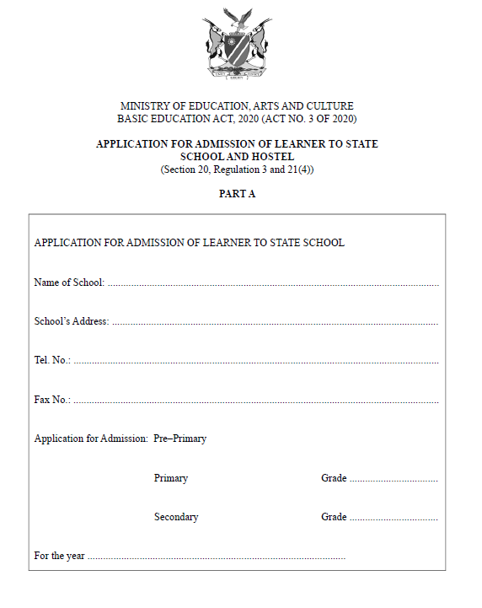

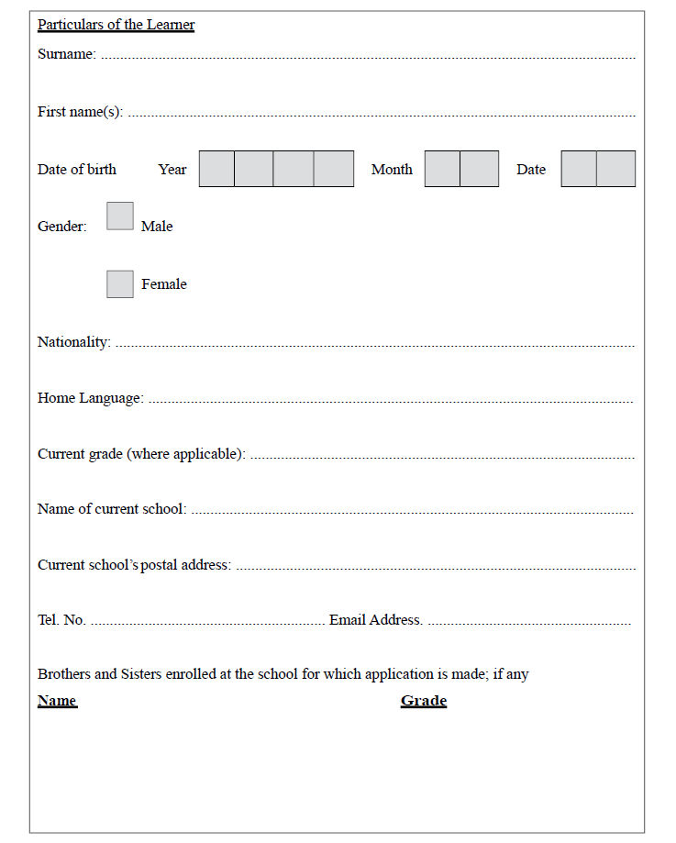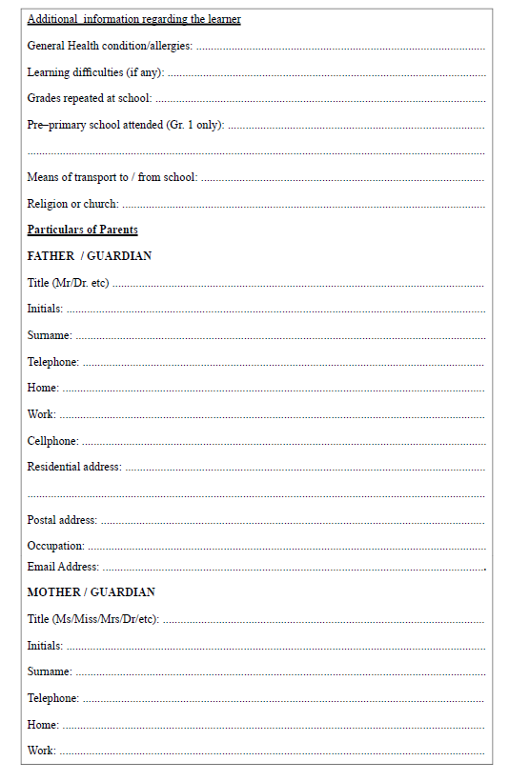

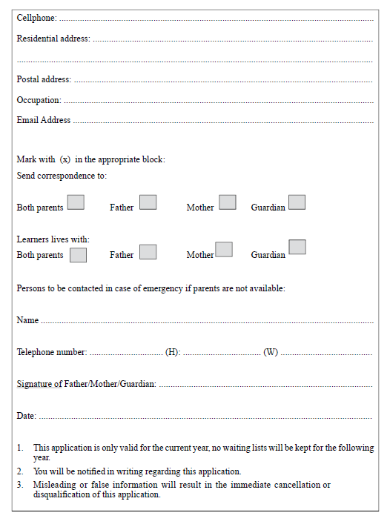

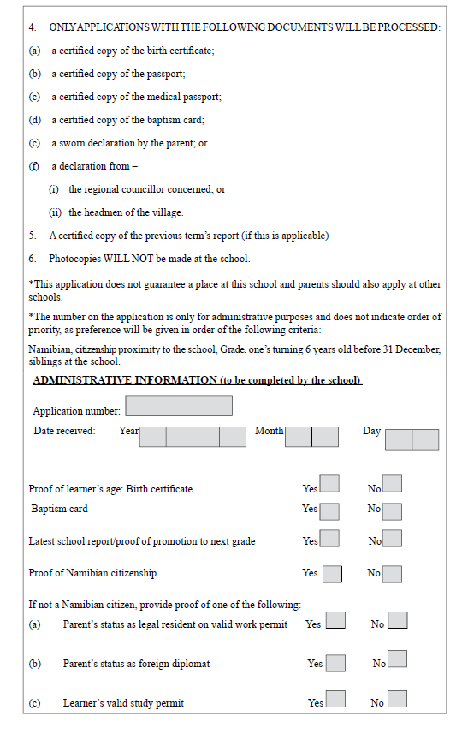

**PART B**

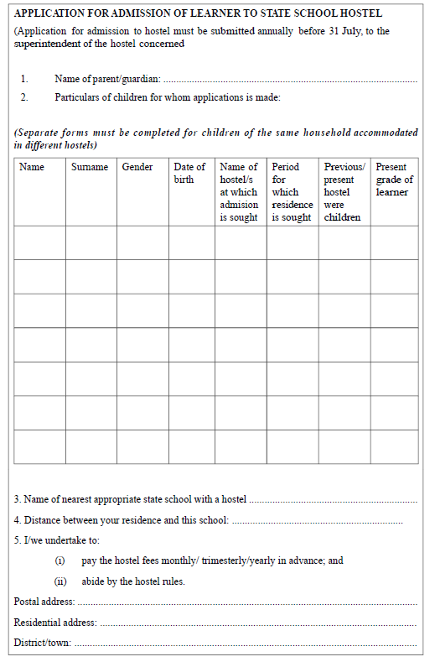

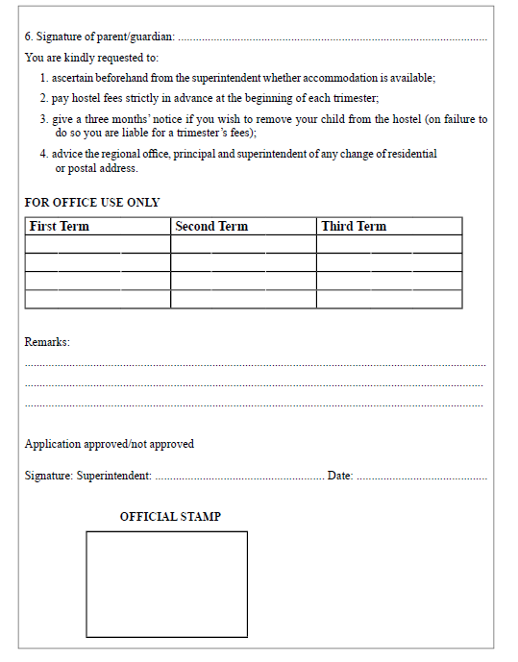

**FORM 2**

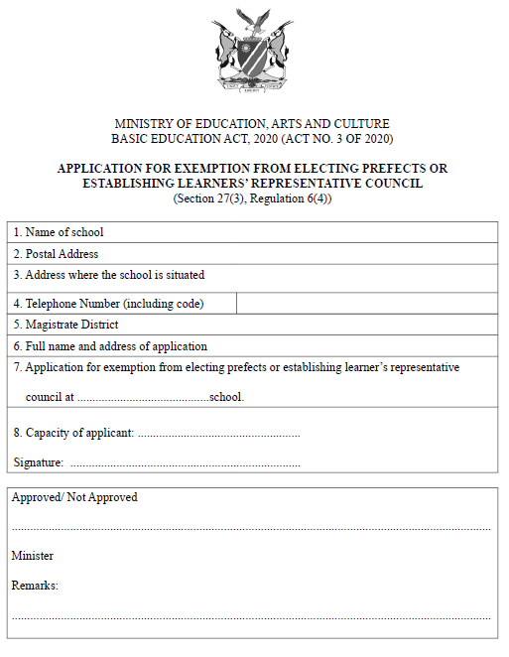

**FORM 3**

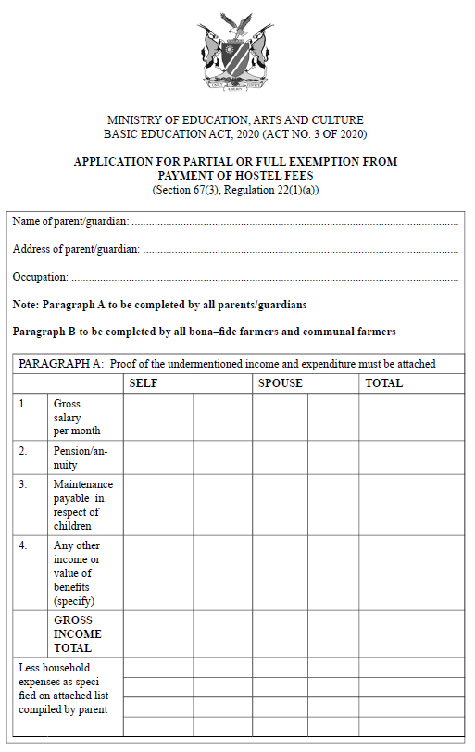

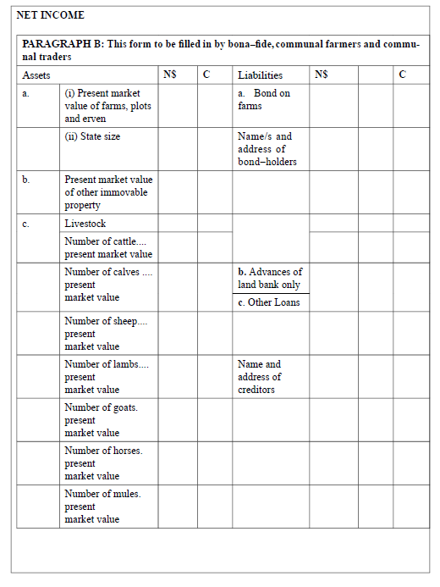 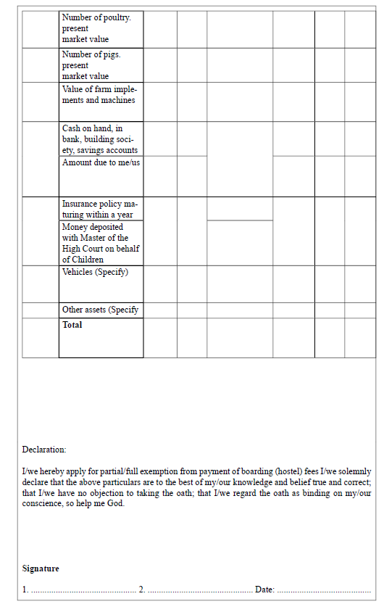

**FORM 4**

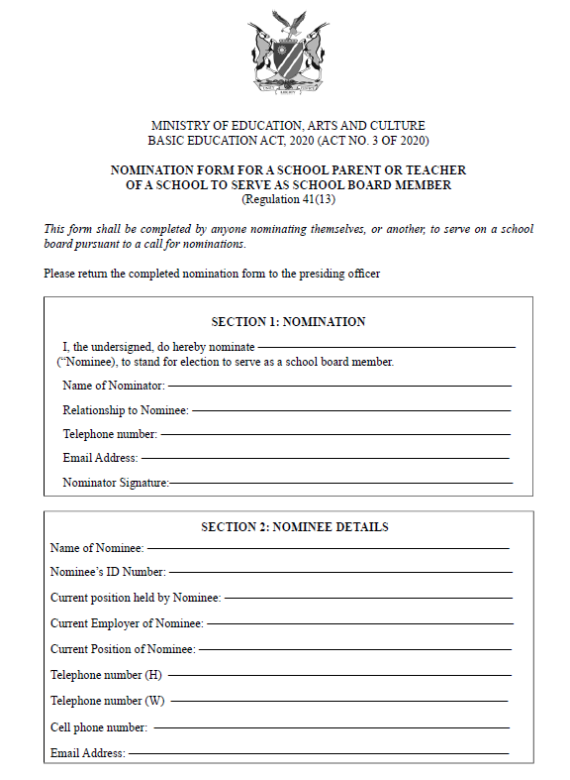

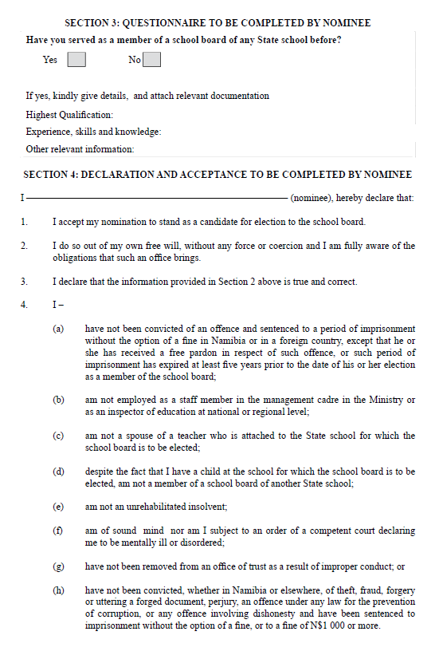

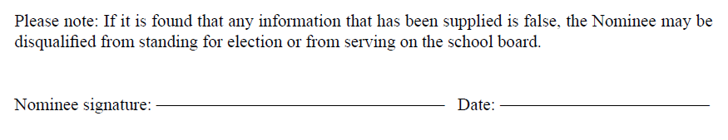**FORM 5**

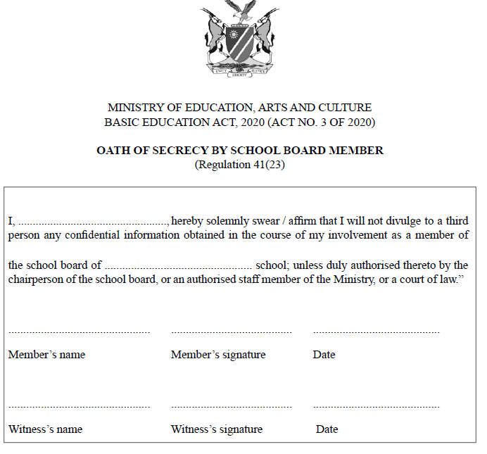

**FORM 6**

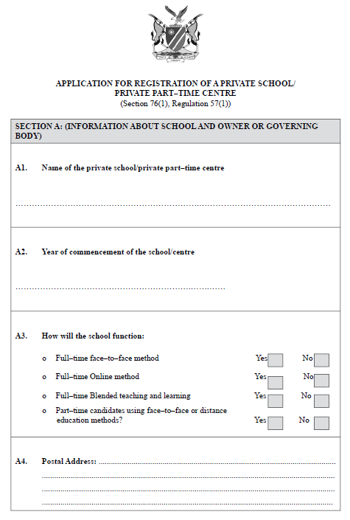

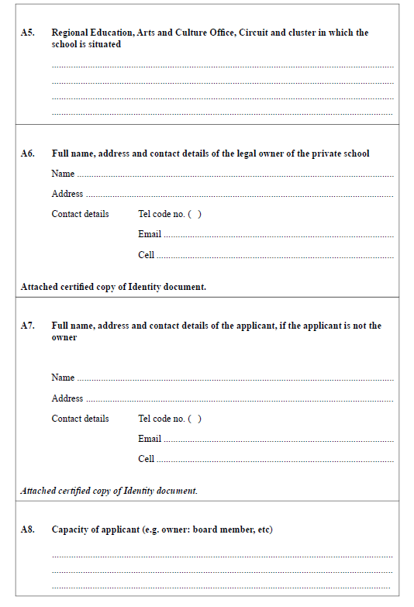

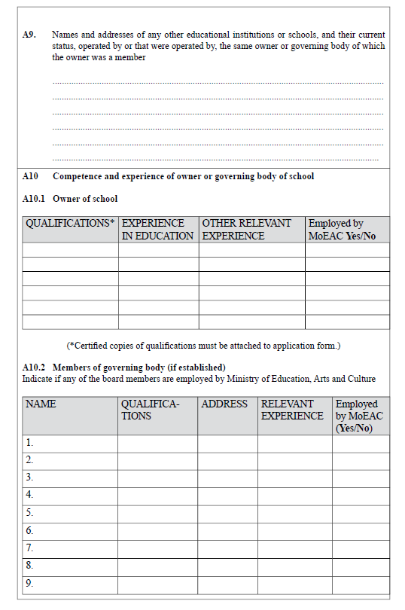

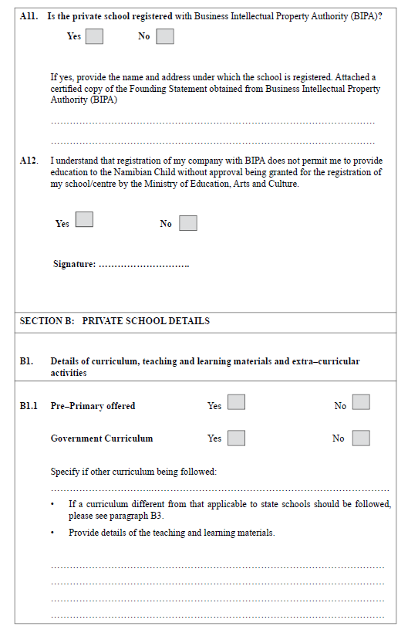

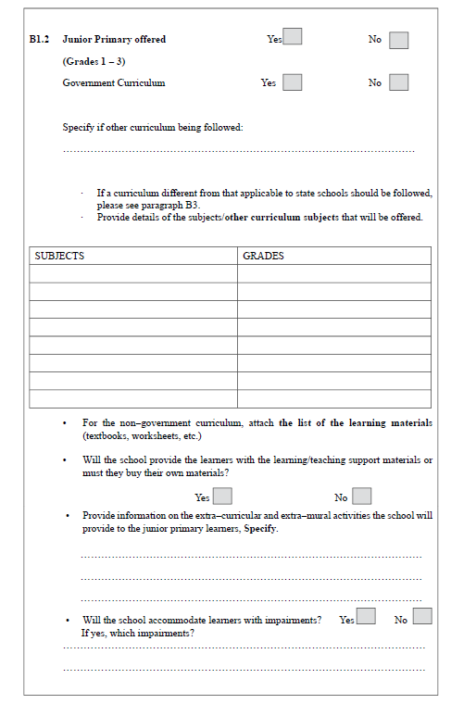

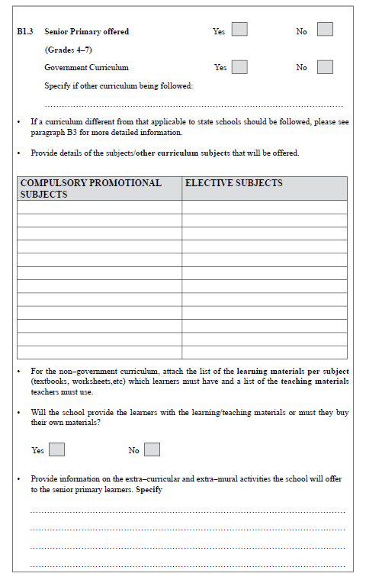

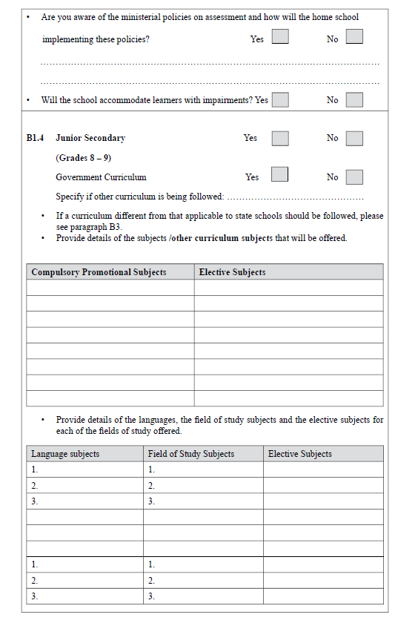

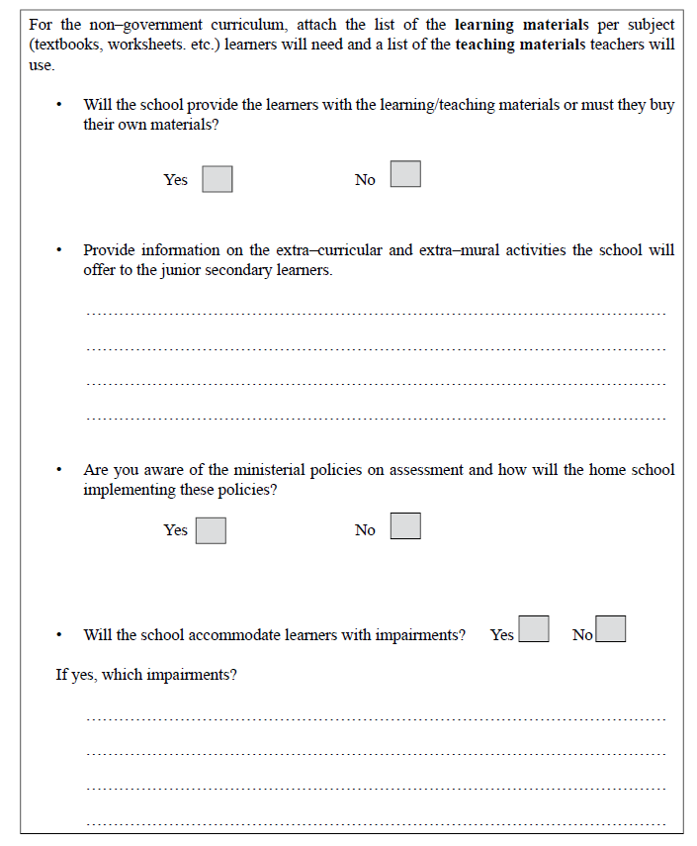

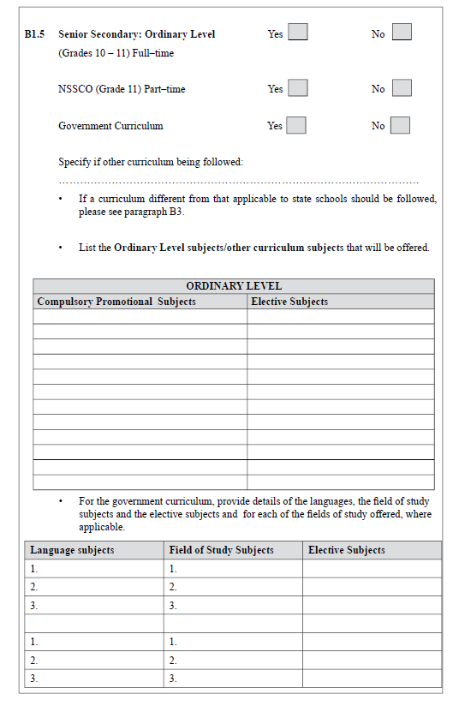

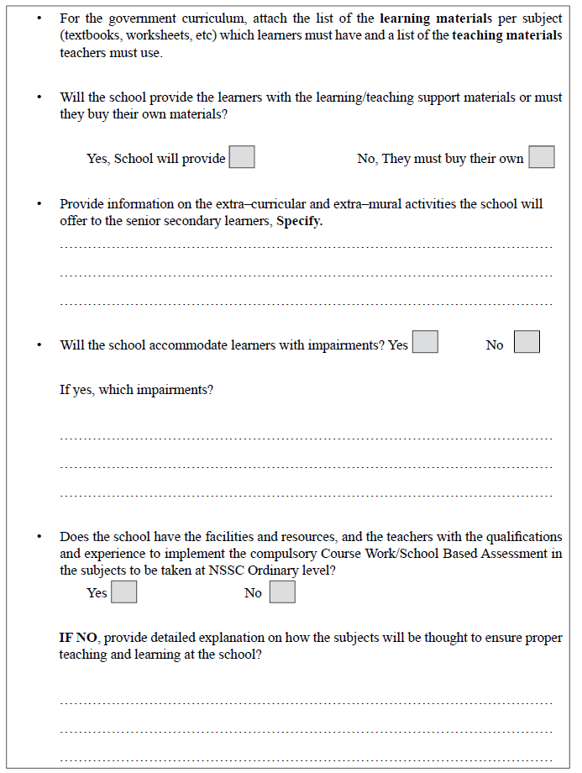

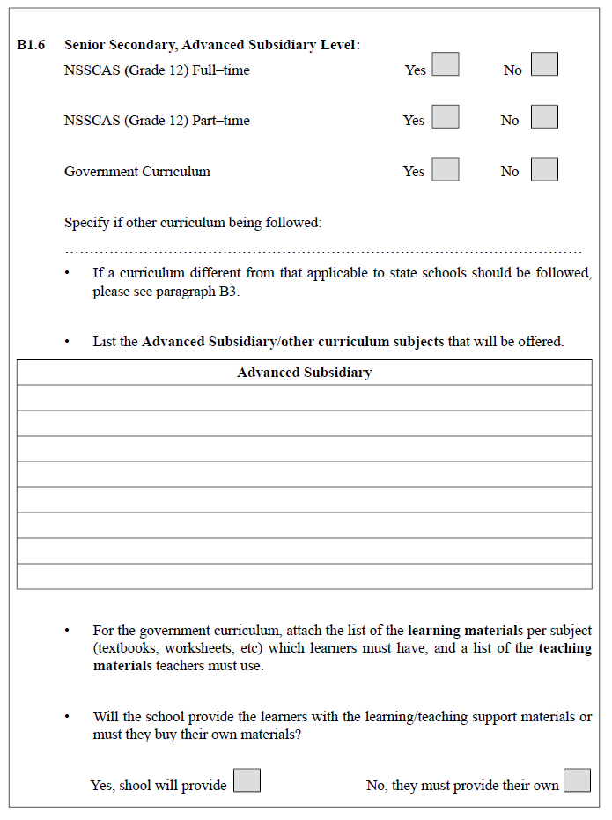

[The word “school” is misspelt in the *Government Gazette,* as reproduced above.]

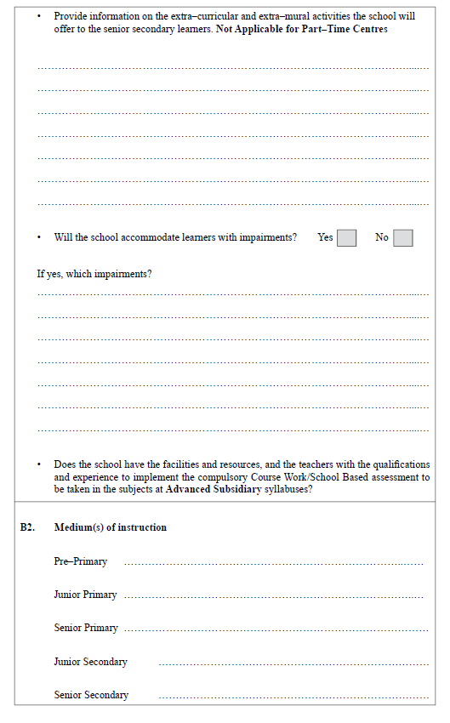

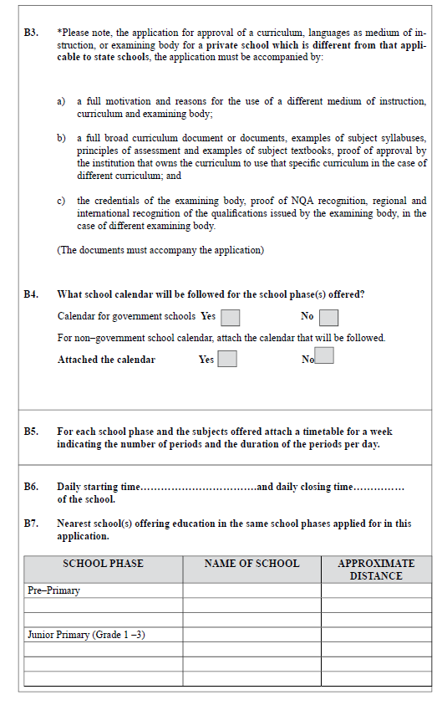

+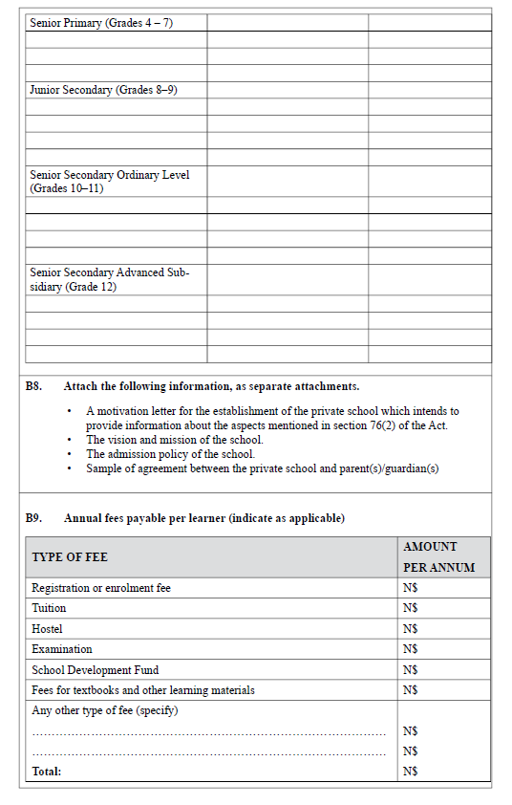

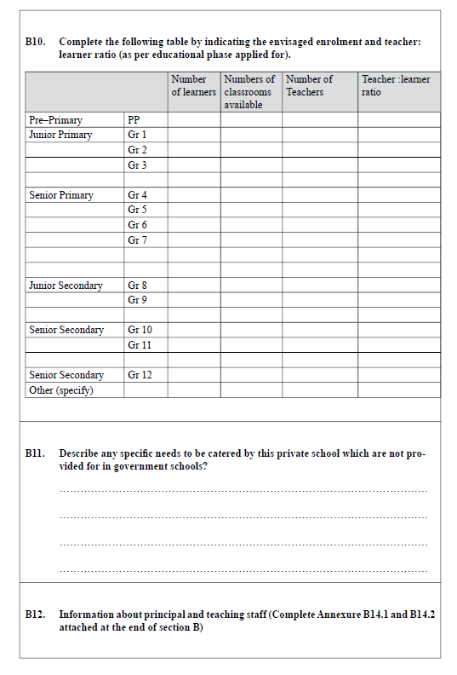

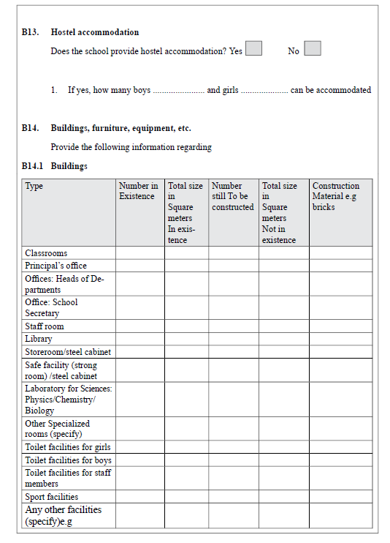

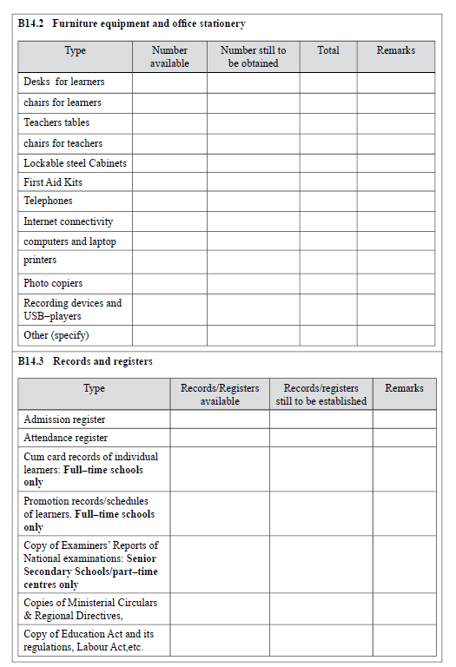

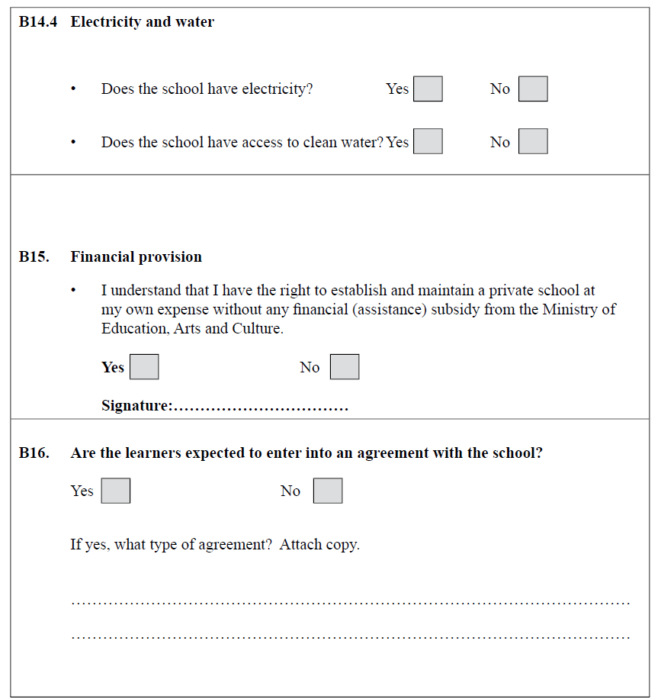

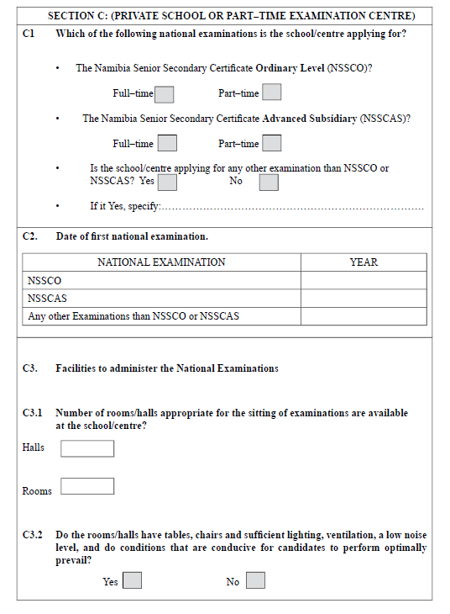

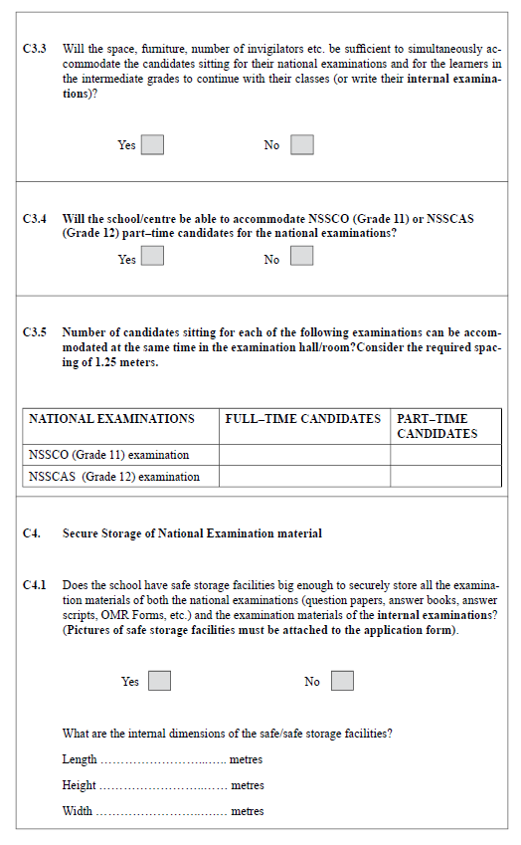

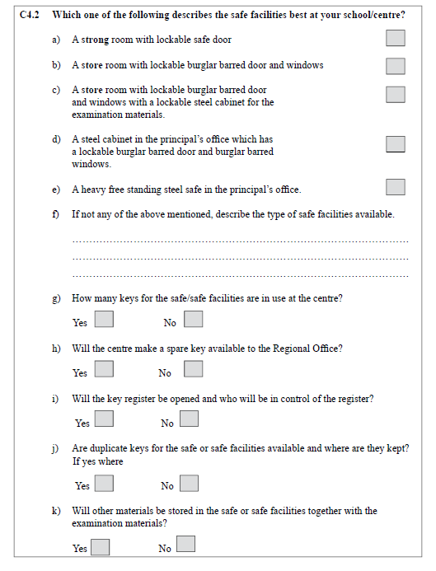 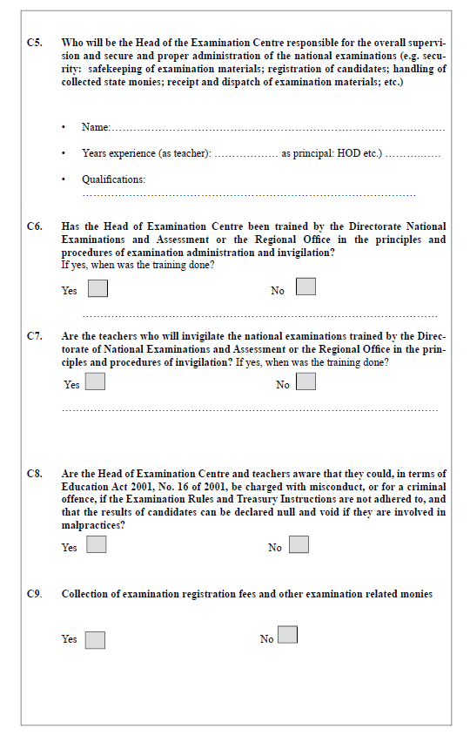

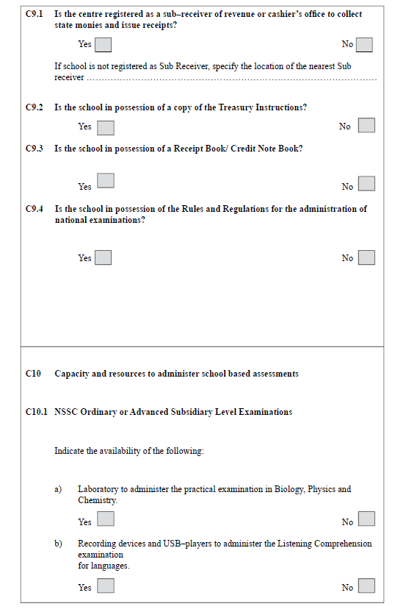

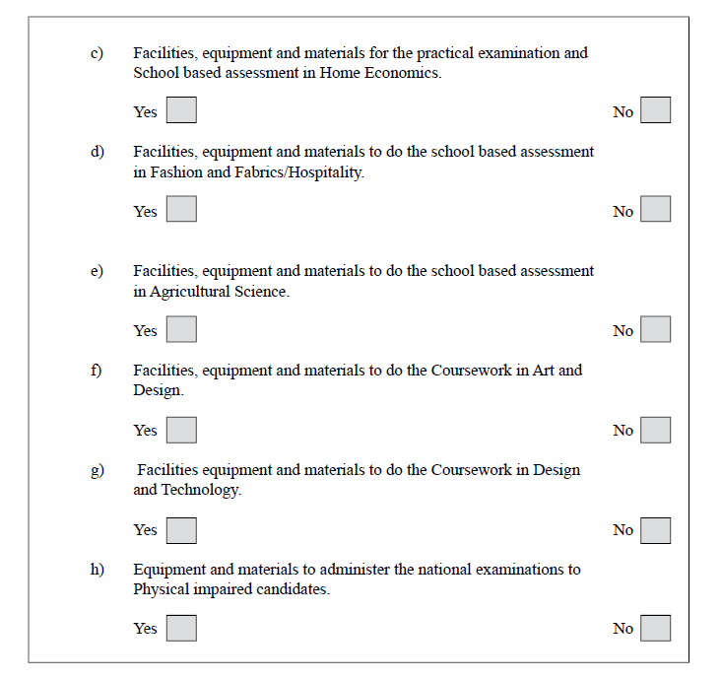

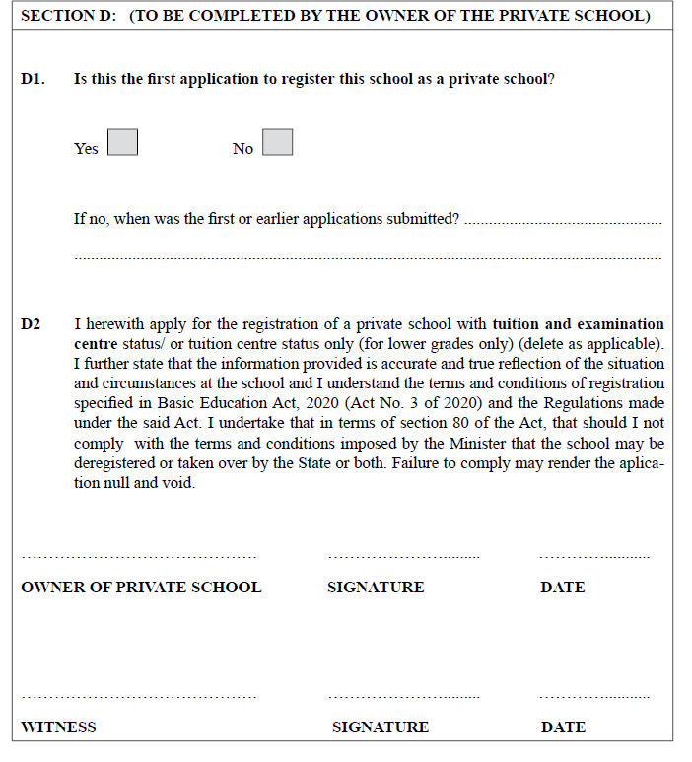

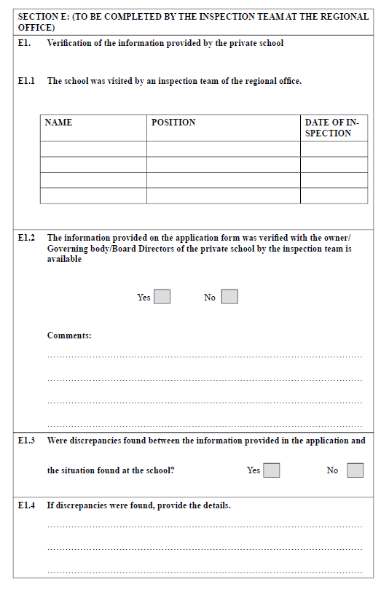

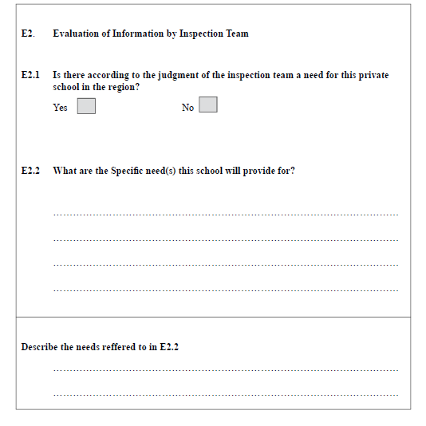

[There is no section E2.3 in this form in the *Government Gazette*.]

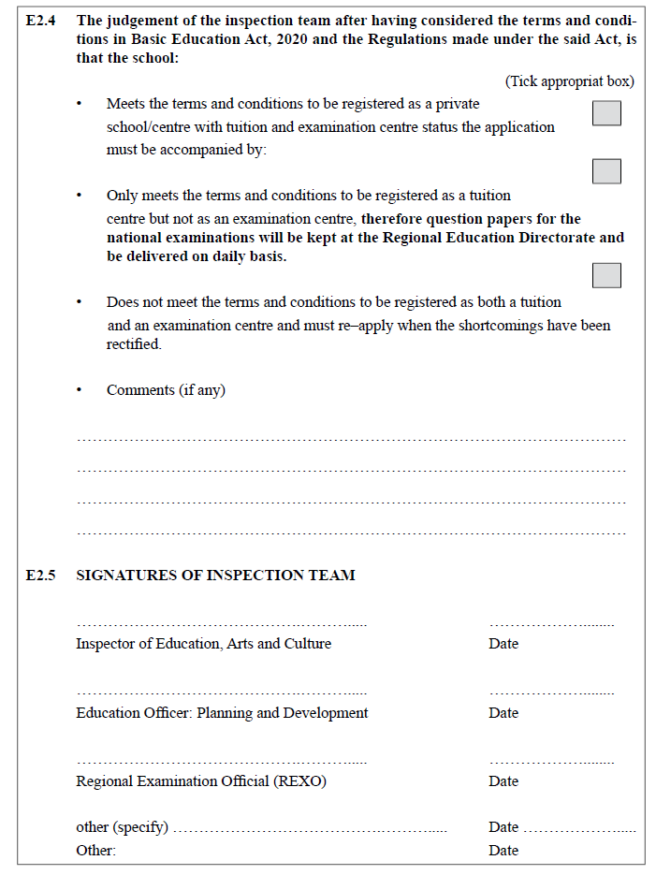

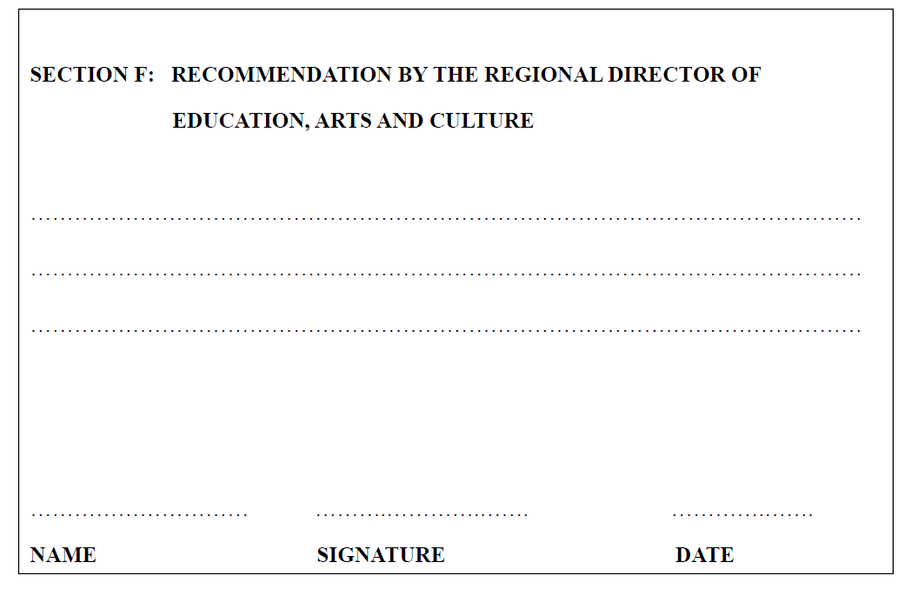

**FORM 7**

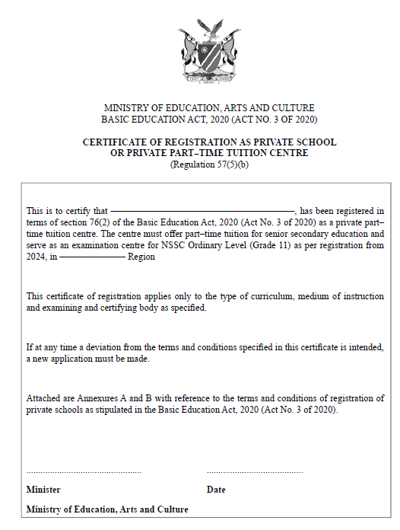

FORM 8

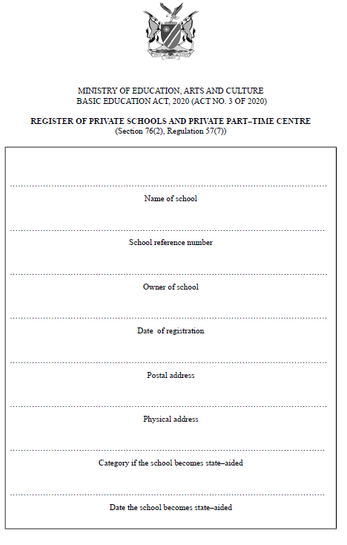

FORM 9

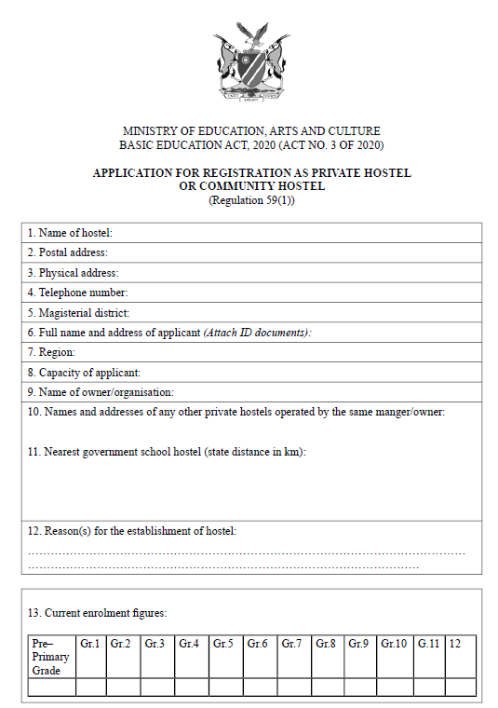

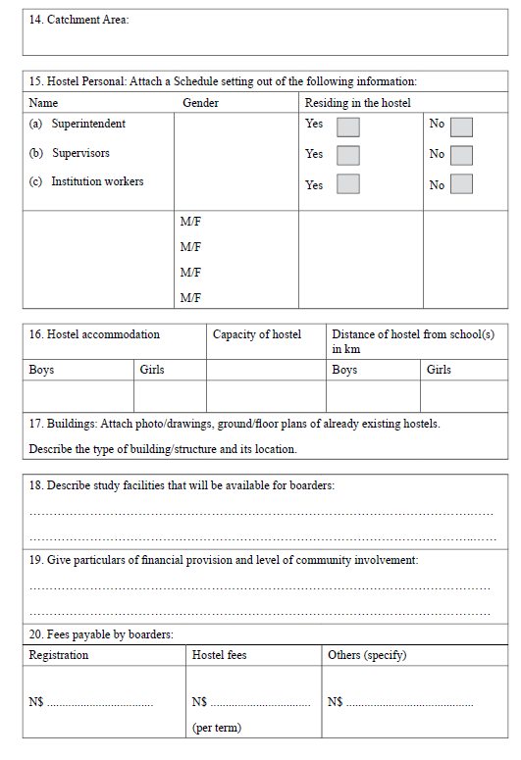

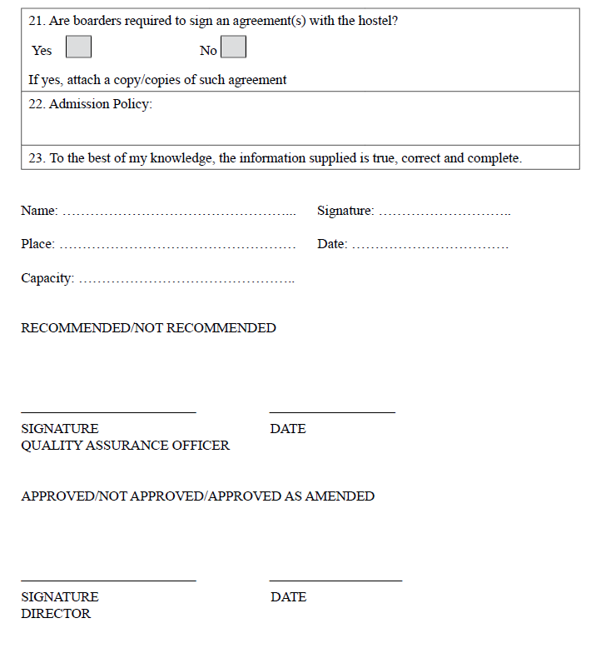

FORM 10

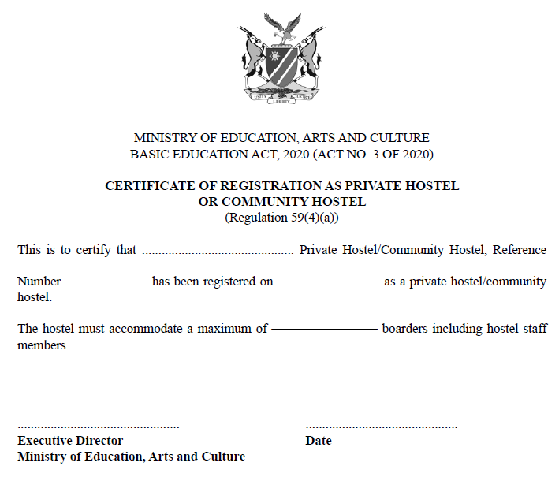

FORM 11

\

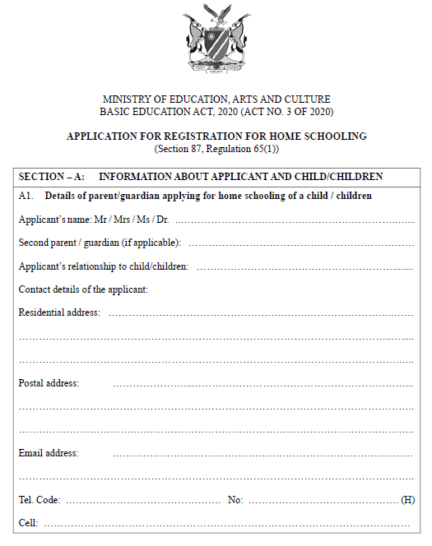

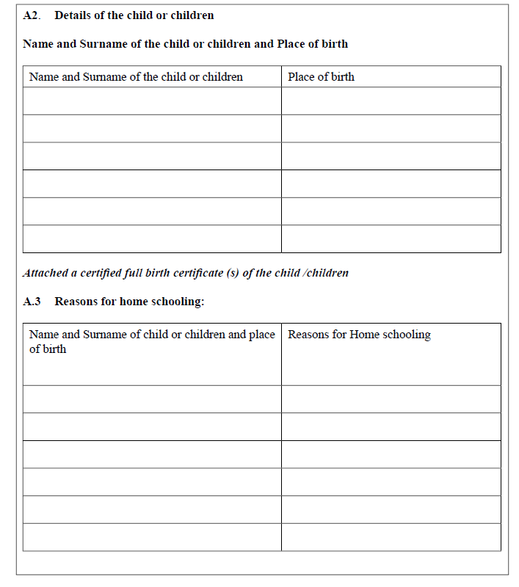

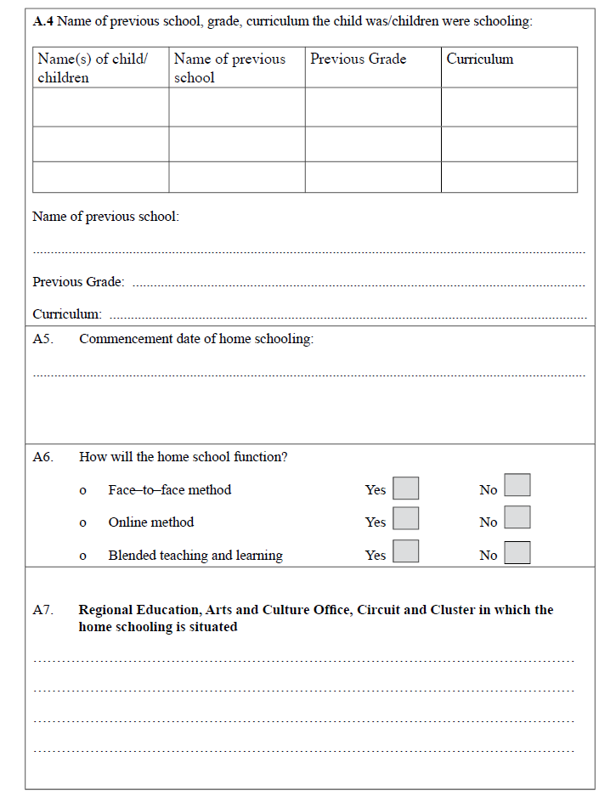

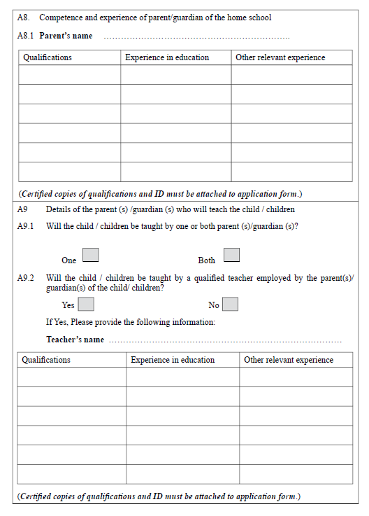

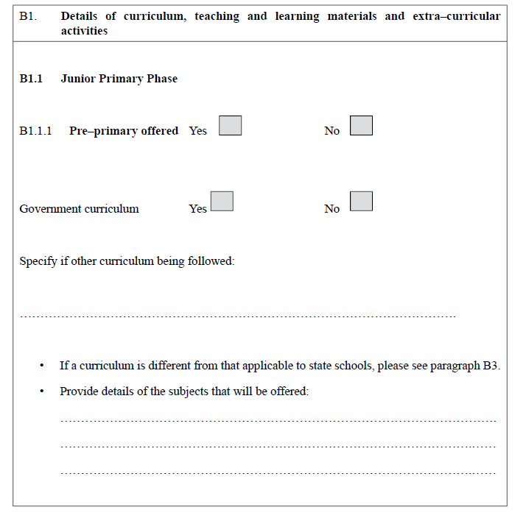

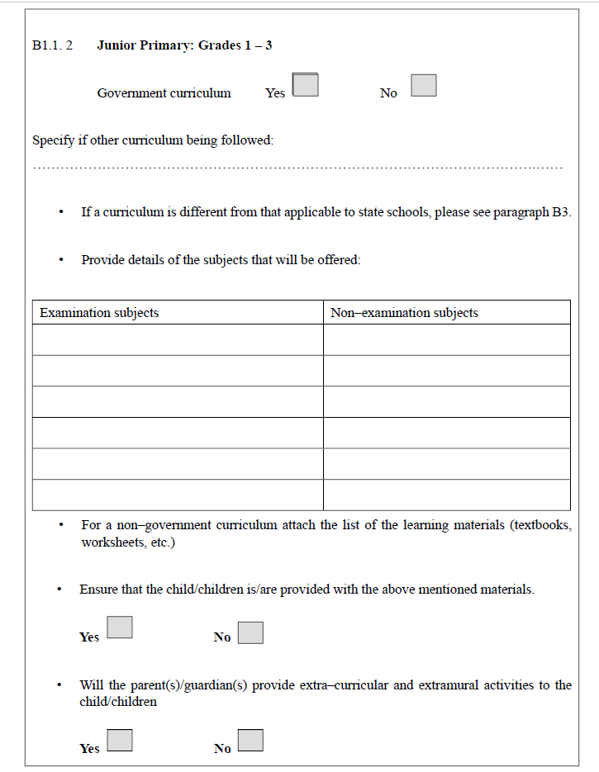

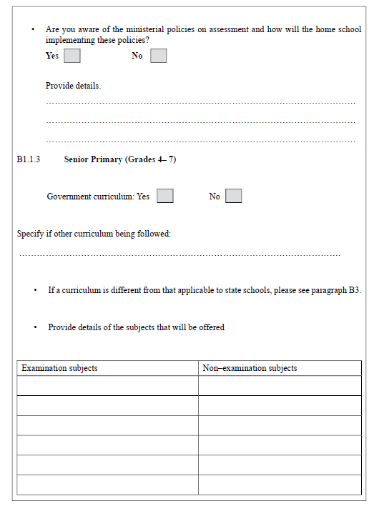

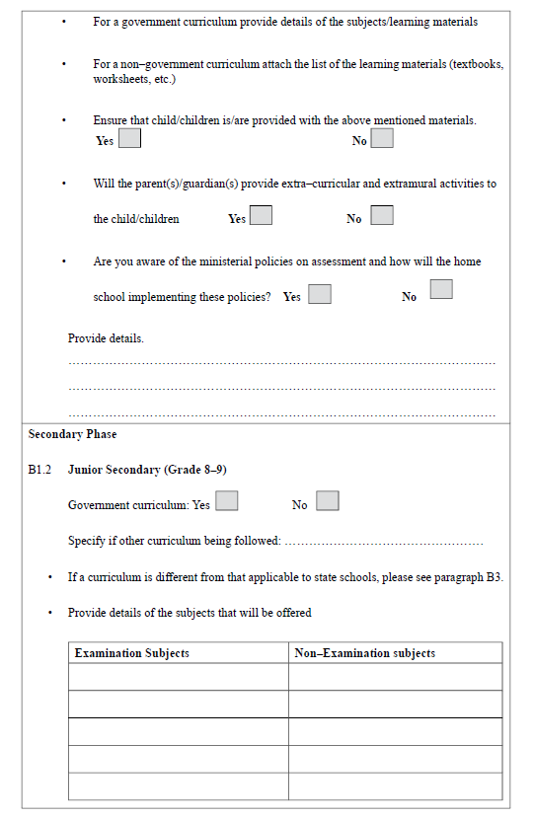

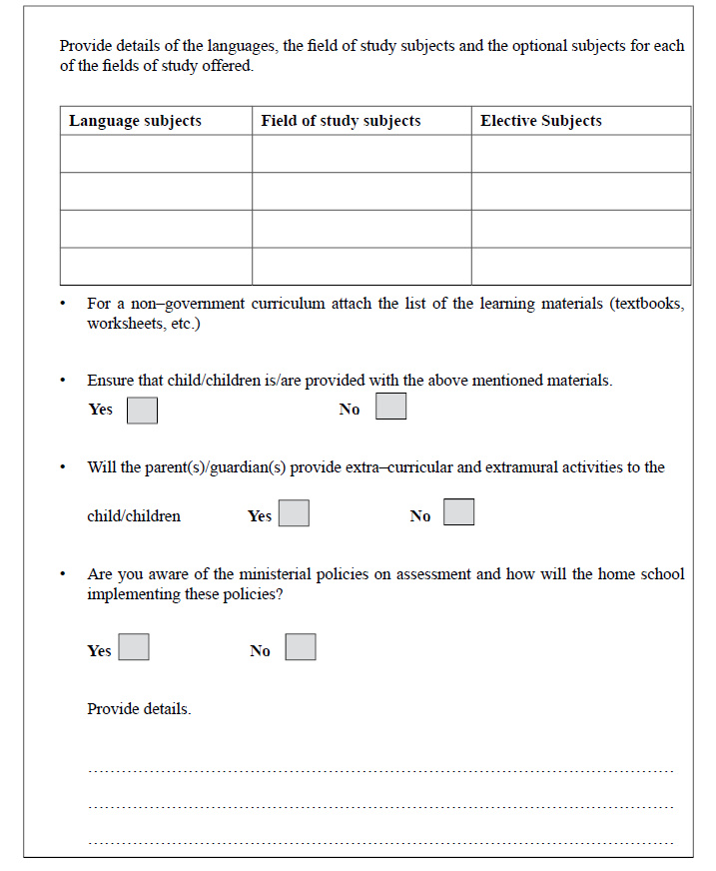

[There are no sections B1.3 and B1.4 in this form in the *Government Gazette*.]

